
RESUME OF
Helal Ahmed
Sodol Pur, Kaligonj
Bishwanath, Sylhet
Mobile: 01722-852182
Email: helalahmedhelal2017@gmail.com

Carrier Objectives

Looking for challenging and rewarding career paths that offer the opportunities for growth and development and an institution where creativity, a sense of responsibility, hard working ability and honesty will appreciate.
Academic Qualification

- Master’of Business Administration: (MBA)
Name of the University : Madan Mohon College, Sylhet.
Major : Management
Result : 1st Class
Passing Year : 2016

- Bachelor of Business Studies: (BBS)
Name of the University : Madan Mohon College, Sylhet.
Course : Degree Pass
Result : 2nd Class
Passing Year : 2014

- H.S.C (Higher Secondary Certificate)

Name of the College : Dakshin Surma Degree College
Group : Business Studies
Obtained GPA : 3.00 (In the scale of 5.00)
Passing Year : 2011
Education Board : Sylhet

- S.S.C (Secondary School Certificate)

Name of the School : Jonokollayan High School
Group : Humanities
Obtained GPA : 3.00 (In the scale of 5.00)
Passing Year : 2009
Education Board : Sylhet

Computer Proficiency
- Computer Skill : Basic Computer Program Course.
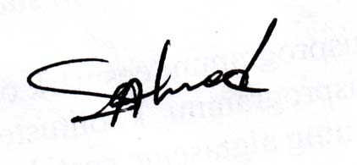
- Internet : Internet Browsing, etc.
Language Proficiency

Language Writing Reading Speaking Understanding

Bengali Excellent Excellent Excellent Excellent
English Excellent Excellent Good Excellent

Personal Information

Name : Helal Ahmed
Father's Name : Abdul Barik
Mother's Name : Joya Bibi
Permanent Address : Vill: Sodol Pur, P.O: Kaligonj Bazar,
PS: Bishwanath, Dist: Sylhet
Nationality : Bangladeshi (By Birth)
Date of Birth : 10-01-1992
Religion : Islam
Gender : Male
Marital Status : Unmarried

Declaration:

I affirm that the above-mentioned information is true and correct in every respect.

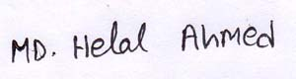
....................... 13-04-2019
Signature

