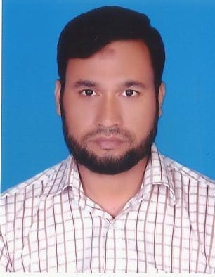

Md. Maksudul Hoq
Shun Shing Power Limited
(An enterprise of Seven Circle Bangladesh Ltd.)
Char Mirpur, Kaligong, Gazipur.
Email: maksudul.uits@gmail.com
Mobile: 01814972692, 01768604960

CAREER OBJECTIVE:
To build up professionally sound and technically skilled career in the field of Electrical and Electronics
Engineering to be a man in the field of my position where I will be responsible, self-driven, willingness to
Learn and strong presence of mind combined with good planning, problem solving and proper decision
Making.

EMPLOYMENT HISTORY : Total experience 12 year’s
1. Name of Company : Shun Shing Power Limited
Section : Power Generation and Distribution.
Char Mirpur, Kaligong, Gazipur.

2. Name of Company : PHP STEEL COMPLEX LTD
Section : Power Generation and Distribution.
Bara Kumira, Sitakunda, Chittagong.

3. Name of Company : BEXIMCO TEXTILE LTD (BTL)
Section : Power Generation and Distribution
Sarabo, Kashimpur, Gazipur.

SUMMARIZED EXPERIENCE:-

- Smooth Operation & Maintenance of a Captive Power plant 15.24 MW (3 nos)
(Rools-Royce B35:40V12 AG.
- Operation & Maintenance of 20 MW (2 nos) ALSTOM gas Turbine which is PLC control based.
- Operation & Maintenance of 10 MW (10 nos) WARTSILA gas Generator.
- To ensure everyday supervise Gas Turbine, Gas Compressor, Air Compressor, Motor, Transformer and all auxiliary equipment.
- Preventive and schedule maintenance of ALSTOM Gas Turbine, Gas Compressor, Air Compressor.
- Handle and Operate of SCADA & DCS System
- Practical experience of trouble shooting of SIMEANCE S7-1200, YOKOGAWA NFCP050, OMRON CS1G-CPU43H control system.
- Alternator (Converteam, AVK) cleaning by (CO2)
- Bearing Change of Motor & Alternator (DE side & NDE side)
- Supervise and maintenance LT, HT, CT, PT installation in ACB, VCB & Alternator.
- Oil mist detector fault finding and troubleshooting & Adjusting Cylinder Deviation.
- I/P change & Calibration (Gas & PCC) & sensor fault finding and troubleshooting.
- Supervise of 132/33kv, 33/11kv and 11/0.4kv transmission line with substation.
- Operation & Maintenance of Boiler, Compressor, Pump, Heat Exchanger, Charge Air Cooler etc.
- To maintain shift Diary, Daily performance Report, log sheet, check up list engine (start, stop, trip)
- Prepare total plant maintenance report and repotting to the plant GM and operation director

EDUCATION:
B.Sc. in Electrical and Electronic Engineering.
University of Information Technology and Science (UITS).
CGPA : 3.32
Passing year : 2014

Diploma in Engineering (Electrical Technology)
Feni polytechnic Institute, Feni.
CGPA : 2.98
Passing year : 2007

Secondary School Certificate (S.S.C.)
Feni Govt. pilot High School, Feni.
GPA : 3.63
Passing year : 2002

COMPUTER SKILLS: MS Office (Word, Excel, PowerPoint).

TRAINING: 12(Twelve week Industrial Training on EASTEAN CABLES LED.Patenga,Chittagong

Title | Institute | Year | Duration
DCS (Distribut Control System in Industries) | TICI | 2018 | 12 days

PROJECTS/PRESENTATIONS:
Undergraduate project on Wireless Power Transmission up to 2 meter

.
LANGUAGE PROFICIENCY: Fluent Speaking and Writing: English and Bengali.

PERSONAL DATA:
Name : Md. Maksudul hoq
Father’s Name : Md. Akkas Ali prodan
Mother’s Name : Safia Begum
Permanent Address : Vill. West Bishpur, P.O. - Matlab (south), Dist.-Chandpur.
Present Address : Shun Shing Power Limited, (an enterprise of Seven Circle Bangladesh
Ltd.) Char Mirpur, Kaligong, Gazipur.
Date of Birth : July 25, 1987.
Marital Status : Married
Nationality : Bangladeshi
Sex : Mal

REFERENCES:
Md. Kamrul Ahasan(Sr. GM.) Md. Jabed Ullah (G.M)
Shun shing power Ltd. Power Generation and Distribution
Char Mirpur, Kaligong, Gazipur Beximco Industrial Park
Call: 01713018000 Sarabo, Ksimpur, Gazipur
Call:
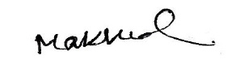
.

Maksudul

.

