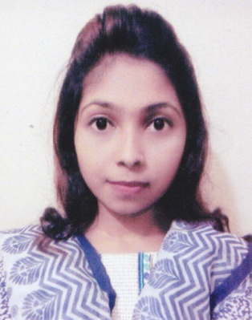
Curriculum Vitae

Hridi Paul
Roynagar, Sylhet
Cell: +88 01679 727014
E-mail: hridipaul55@gmail.com

Career Objective

To work as a virtual assistant which provides me the opportunity to improve my skills and knowledge to growth along with the organization objective.

Academic Details

Computer Science & Engineering
Institute : Metropolitan University, Sylhet
Year : 2014-2018
Result : 3.17/4

Higher Secondary Certificate (H.S.C)

Institute : Moulvibazar Govt. College
Board : Sylhet.
Result : 4.90/5
Passing Year : 2013

Secondary School Certificate (S.S.C)

Institute : Ali Amzad Govt. Girls High School
Board : Sylhet
Result : 5.00/5
Passing Year : 2011

Skill

- Language : C, PHP, HTML, CSS, Javascript
- Database : MySQL
- Framework : Bootstrap, Laravel.

Academic Projects (Web Application)

- Project 200:
Library Management System
- Project 300:
Class Forum
- Web Programming:
Online examination
- Project 400:
Art Gallery

Personal Information:
- Name : Hridi Paul
- Father’s Name : Sunirmal Paul
- Mother’s Name : Anima Paul
- Date of Birth : 07-04-1995
- Religion : Hindu
- Sex : Female
- Nationality : Bangladeshi
8. Marital status : Unmarried

