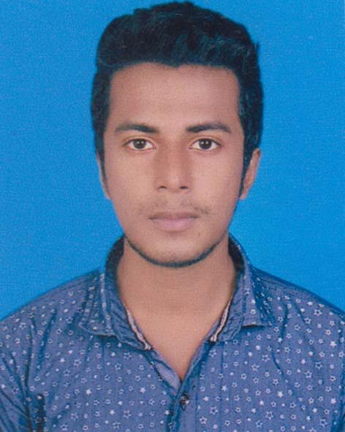
Curriculum vitae
Of
Mehedi Hasan Ridoy
Cell: 01632-565722
Email: mh446901@gmail.com
Present address:
Village - Kandania, Post-Office - Kandania, Police Station - Fulbaria District - Mymensingh.

Permanent address:
Village - Kandania, Post-Office - Kandania, Police Station - Fulbaria District - Mymensingh.

Career Objective
I would like to build up my career in a well-known organization through using my creativity, efficiency and hard working so that my respective organization can achieve its goal in the circumstances of the global challenging and competition. I always prefer to take the challenging opportunities for building up myself.

Self-Assessment
A self-driven attitude, willingness to learn and a strong presence of mind.
Optimistic, confident and benevolent.
Energetic, devoted, sincere and hardworking.
Academic Qualification
Name of exam | Group/ sub | Year of passing | Institute/ versity | Results: division / CGPA
SSC / Dakhil | Science. | 2014 | Kandania High School, Fulbaria, Mymensingh. | 4.50
HSC / Alim | Humanities. | 2016 | Shahabuddin Degree College (Asim), Fulbaria, Mymensingh | 4.25
B.A (Hon’s) | Political Science | 2nd Year Running | Govt.Titumir College, Dhaka

Job Experience
Institutions | Position | Duration
Unilever Pureit | Sells Manager | 6 months
Shwapno Aci Logistics | Sells Manager | Running

Language Proficiency
Confident Enough To Communicate Both In Bengali And English
Language | Listening | Reading | Writing | Speaking
Bengali | Excellent | Excellent | Very Good | Very Good
English | Excellent | Very Good | Very Good | Very Good

Computer Literacy
1. | Operating system | Windows 7, 8.1 & 10.
2. | Word processing | Microsoft word
3. | Spread sheet analysis | MS Excel, MS Access
4. | Presentation | MS Power Point
5. | Special | Internet Browsing.

Personal Profile

Name: Md. Mehedi Hassan Ridoy

Father’s Name: Md. Anuarul Islam

Mother’s Name: Moriom Begum

Date of Birth: 18th April 1998.

Height: 5.5”

Blood Group: B+

Religion: Islam

Marital Status: Unmarried

Nationality: Bangladeshi

NID: 19986112029000100

………………………………
Md. Mehedi Hassan Ridoy

