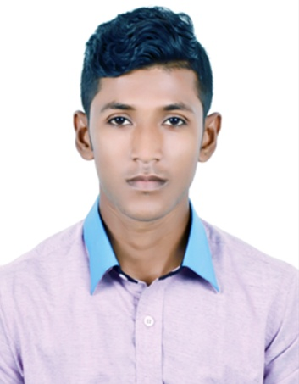

CURRICULUM VITAE OF
IBRAHIM ALI

House No-65, Old Medical Colony, Abu-Sina Hostel,Ketripara,Sylhet-3100.
Personal Number: 01726-527706
Email: miahalomgir00@gmail.com

CAREER OBJECTIVE

Position requiring innovative, challenging employment that will utilize educational qualification and professional skills and offer advancement opportunity for the field.

ACADEMIC CREDENTIALS

Higher Secondary Certificate
- Board : Sylhet Board
- Institute : Madan Mohan College, Sylhet.
- Group : Business Studies
- Year of Passing : 2012
- Result : GPA: 3.70

Secondary School Certificate
- Board : Sylhet Board
- Institute : Rasamoy Memorial High School.
- Group : Science
- Year of Passing : 2010
- Result : GPA: 3.94

COMPUTER SKILLS

- Have good knowledge in Microsoft Word, Excel, Power Point.
- Have good knowledge of using Internet & E-mail.

LANGUAGE EFFICIENCY

- Good writing and oral communication ability in English and Bengali.

Page 1 of 2

EXTRA-CURRICULAR ACTIVITIES

- Good representation ability.
- Enthusiastic in challenging working field.

PERSONAL DETAILS

- Father’s Name : MD. Alamgir Ali
- Mother’s Name : Lily Begum
- Date of Birth : 04-07-1994
- Nationality : Bangladeshi (by birth)
- Sex : Male
- Marital Status : Unmarried
- Religion : Islam
- Home District : Sylhet
- Permanent Address :Lakhaura Islampur,Po:Lakhaura,P.s:Airport,D.s:Sylhet-3100
- Present Address : House No-65,Old Medical Colony, Abu-Sina Hostel, Ketripara
- Contact Number : Personal Mobile No: 01726-527706,01625-912386

I hereby declare that the information given above correct to the best of my knowledge.

Signature

..............................
(Ibrahim Ali)

Date : .........................

Page 2 of 2

