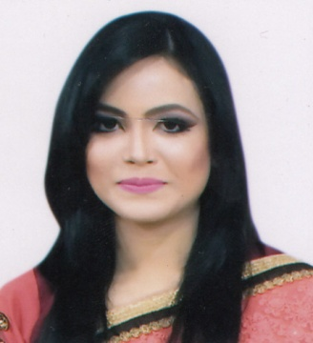
Curriculum Vitae of
Beauty Akhter Ima
Address: 59/4 Nurani, Subid Bazar, Sylhet-3100.
Contact No.: 01705997809 (Personal), 01913587049 (Home)
E-mail: ima_3355@yahoo.com

Career Objectives
To build a career that encounter challenge and creativity, being a professional worker to enrich the decision making ability through my aptitude, hard-work, dedication and determination and to work in a challenging position which requires special skills and abilities. I would welcome the chance to work as a part of a dynamic team where I could make a significant contribution while developing my skills yet further.

Academic Qualification
- Masters of Business Administration (MBA), 2017.
Major in: “Finance & Banking”.
Institution: Leading University, Sylhet.
CGPA: 3.98 out of 4.00
- Bachelor of Business Administration (BBA), 2016.
Major in: “Finance & Banking”.
Institution: Leading University, Sylhet.
CGPA: 3.89 out of 4.00
- Higher Secondary Certificate (HSC), 2012.
Institution: Blue-Bird School & College, Sylhet.
Group: Business Studies
GPA: 5.00 out of 5.00
- Secondary School Certificate (SSC), 2010.
Institution: Govt. Agragami Girls High School & College, Sylhet.
Group: Business Studies
GPA: 4.50 out of 5.00
Training
- Internship Program at: Southeast Bank Limited, Chowhatta Branch, Sylhet.
Duration: 3 months (From October 05, 2016 to January 05, 2017)

Computer Skills
- Operating system: Windows (XP, Vista, Seven, windows 10).
- Office automation: Microsoft (Word, PowerPoint, Excel).

Language Proficiency
- Bengali (Mother Tongue)
- English (Fluent in listening, speaking, reading & writing)
- Hindi (Conversational)

Major Attributes of Character
- Strong desire for leading an honest life with dignity.
- Hard working, sincere & eager to learn.
- Strong determination to attain goals.
- Able to take responsibility.

Interests
- Participating in creative and smart work.
- Traveling, listening music, reading articles & journals.
- Watching movies.

Personal Details
Name : Beauty Akhter Ima
Father’s Name : Kholil Ahmed
Mother’s Name : Shamima Begum
Date of Birth : January 02, 1994.
Blood Group : O (+ve)
Gender : Female
Nationality : Bangladeshi
Marital Status : Single
Religion : Islam
Permanent Address : Village: Bagha, P.O: Gulapgonj, Sylhet.
Present/Mailing Address : House No. 59/4 Nurani,Subid Bazar, Sylhet.

References
Md. Jahangir Alam  Assistant Professor  Department of Business Administration  Leading University, Sylhet.  Contact: 01711009899  E-mail: jalam160@lus.ac.bd | Mohammad Zahed Hossain  Senior Lecturer  Department of Business Administration  Leading University, Sylhet.  Contact: 01816555545  E-mail: zahedbtc@gmail.com
Signature
I do hereby certify that all information stated in this resume is true and correctly describes my qualifications and myself to the best of my knowledge.
Sincerely,
____________________
Beauty Akhter Ima

