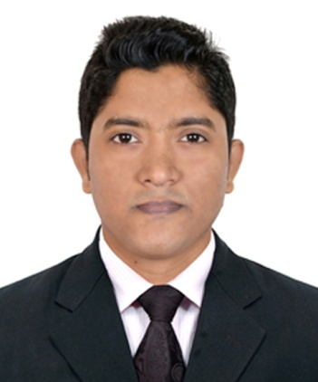
Resume
Of

Md. Imnur Rahman
Address: Village: Tiloy, Post: Tiloy, Upazila: Damudya,
Dist: Shariatpur.
Home: 01758-461054
Mobile: 01765-981979
E-mail: emonahmed1991@gmail.com
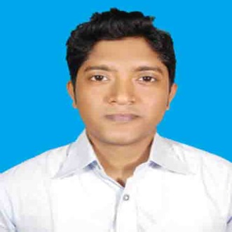
Career Objective:
To work in a challenging environment offering B. Sc in Computer Science & Engineering Degree of performance where I can noticeably contribute to an organizational success.

Career Summary:
I would like to be a part in a well reputed organization where my potentialities can be utilized efficiently and effectively by doing innovative any job.

Computer Skill:
C, C++, Cisco Packet Tracer (CCNA), Microsoft Office Application.

Academic Qualification:
Exam Title | Concentration/Major | Institute | Result | Pass.Year | Duration
B.Sc In Computer Science and Engineering | CSE | World University Of Bangladesh | CGPA:3.50  out of 4 | 2016 | 4 Years
Diploma in Engineering | Computer Technology | Shariatpur Polytechnic Institute | CGPA:3.27  out of 4 | 2011 | 4 Years
S.S.C | Business Study | Kaneshwer S.C. Edward Institution | CGPA:4.31  out of 5 | 2007 | -

Training Summery:
Training Title | Topic | Institute | Country | Location | Year | Duration
CCNA | Routing and Switching | CSL Training | Bangladesh | Dhanmondi,27 | 2016 | 4 Month
Windows Server 2003 | DNS setup and Server 2003 configuration | New Horizons computer learning Center | Bangladesh | Dhanmondi,6 | 2010 | 3 Month

Self Potentiality:
  - Having Positive attitude towards learning.
  - Practical, Persuasive and ready to face challenging task.
  - Able to work under stress and meet dead line.

Career and Application Information:
Looking For | : | Entry level
Available For | : | Full time
Preferred Job Category | : | Well reputed institution
Preferred District | : | Dhaka
Preferred Country | : | All over country in the world.
Preferred Organization Types | : | Banks, Telecommunication, Software Companies, IT Enabled Service, Trading or Export/Import, Shipping.

Language Proficiency:
Language | Reading | Writing | Speaking
Bangla | High | High | High
English | High | Medium | Medium

Personal Details :
Name : Md. Imnur Rahman
Father’s Name : Abdul Jabbar Sarder
Mother’s Name : Morsheda Begum
Permanent Address : Vill: Tiloy, P.O: Tiloy, Upazila: Damudya, Dist: Shariatpur
Present Address : Building No: 17, Flat No: 1502, Japan Garden City, Mohammadpur, Dhaka: 1207.
Date of Birth : 30-11-1991
Sex : Male
Marital Status : Single
Religion : Islam
Nationality : Bangladeshi By Birth
Home District : Shariatpur
References:
MD. Uttam Ali Miah
Member of Finance
Bangladesh Power Development Board.
Mob: 01782890198
References:
Kazi Hassan Robin
Asst. Professor, Dept. of CSE
(Computer Science & Engineering).
World University of Bangladesh.
Mob: 01819-136927

Announcement:

I do hereby declare that the particulars provided here are true and no
misinformation is given.

Sincerely Yours,
Md. Imnur Rahman

……………...
Signature Date:......................

