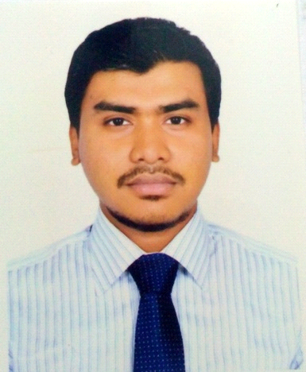
Name: Iqbal Ibn Muzib
Date of Birth: 26-07-1994
Address: 146/3, west rampura, wapda road Dhaka-1219
Mobile: +8801711-084329
E-mail: jaforiqbal@gmail.com
Linkdin Profile: https://www.linkedin.com/in/iqbal-ibn-muzib-41b35bb2/

Profile
I am an enterprising young professional intending to continue my development as executive, business development. I think in term of results and objectives, I am enthusiastic, and I work with decisiveness and conviction. I have a proactive attitude and find positive ways to stimulate and engage with people.

Education

2012-2016 Bachelor in Business Administration (B.B.A)
Southeast University, Banani, Dhaka
Major in Marketing
Average grade: 3.18 out of 4.0

2010-2011 Higher Secondary Certificate (H.S.C)
Gulshan Commerce College, Dhaka
Major in Business Studies
Average grade: 5.0 out of 5.0

2008-2009 Secondary School Certificate (S.S.C)
A.U.N Kamil Madrasah, Dhaka
Average grade: 5.0 out of 5.0

Professional Experience

01/2013-14/2015 Grameenphone Limited, Bashundhara, Dhaka
As customer manager with good reputation in Telecommunication.

01/2016 - continue A.S Printing and Packaging, Demra, Dhaka.
As Business Development Manager with good reputation.

Extracurricular Activities

10/2014-20/2015 President, Cultural Club Committee, Southeast University

Skills

- Training Completed: Communicative Skills for Professional
- Languages: Bangla (Mother Tongue), English (Good spoken and written command)
- Computer: Basic MS Office and hardware.

Interests & Additional Information

Backpacked traveler, Computer operating, learning new languages and testing new foods.

Reference

Yasser Arafat (Supervisor) Md Shabbir Ahmed
Grameenphone Ltd, Principal Officer
Inbound contact center Al-Arafah Islami Bank
Cell: 01711501398 01714496816

Signature
Iqbal Ibn Muzib

