ISMAIL HOSSAIN | 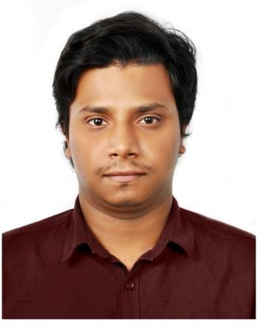
House-26, Road-North Circular, Dhanmondi, Dhaka, 1205, Bangladesh
+8801685953005, 01730482852
ihsyam27@gmail.com
Sex: Male | Date of birth: 10/11/1996 | Nationality: Bangladeshi

CAREER OBJECTIVE
To join a renowned Institution to enhance my skills and knowledge and to work for the growth of the
Institution.

EDUCATION
Bachelor of Business Administration (BBA)
United International University Major: Accounting
CGPA: 2.66 (Completion: September 2019)

Higher Secondary Certificate(HSC)
Dhaka Commerce College Business Studies
GPA: 5.00 (Completion: 2014)

Secondary School Certificate (SSC)
BCSIR High School Business Studies
GPA: 4.19 (Completion: 2012)

Extra Curriculum Activities
- Worked as a Sales Promoter at Sesame Workshop Bangladesh Book Fair 2017 and 2018
- Participated in “The Excelist 2018 powered by Hero” competition organized by Finance Forum held at UIU.
- Joined many career workshops & seminars organized by UIU CCC held at UIU.
- Participated in “Accounting Olympiad- Battle for glory in 2018” competition organized by UIU Accounting Forum held at UIU.
- Participated in the “Pro excel 2.0- an Intra University Excel Training & Competition 2017” Organized by UIU Finance Forum held at UIU.

Additional Information & Skills

Interpersonal Skills
- Honest
- Well communicator
- Friendly
- Sufficient presentation Skill
- Sincere
- Modest

SEMINAR
- Meet With The Managing Directors, 2018
- Seminar on Investment & Portfolio Management-2016

LANGUAGE
- Bangla: Fluent in Speaking and Writing
- English: Fluent in Speaking and Writing

COMPUTER SKILLS
- MS Office Application (Word, Excel & PowerPoint)
- Proficiency in AIS software (QuickBooks), Emailing and internet surfing.

REFERENCES  Dr. James Bokul Sarkar  Associate Professor &  Deputy Director, BBA Program United International University Mobile: 01716599599  Email: jmssarkar@bus.uiu.ac.bd | Mofijul Hoq Masum(ACMA)  Assistant Professor  School of Business Economics United International University Mobile: 01558965046  Email: masum@bus.uiu.ac.bd

