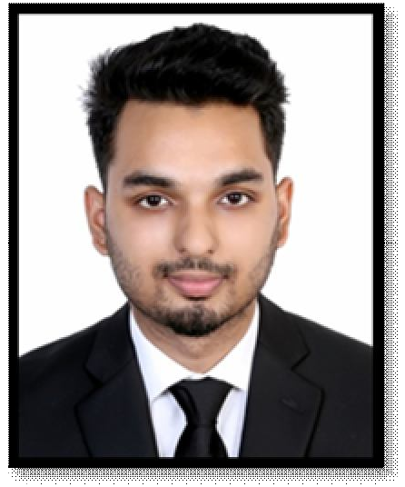
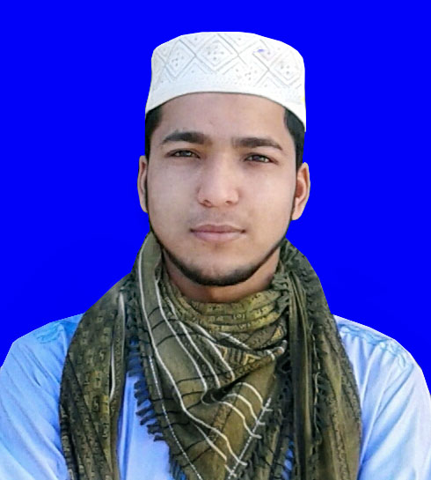

JALAL UDDIN RUME

Vatalia,Rikabi Bazar,Sylhet.
Cell: +88 01757705379
E-mail: jalalrume111@gmail.com

Carrer objective
Rendering of conceptual and organizational skills along with creativity, dynamism, enthusiasm and thus making position in corporate world. Moreover, enhancing and developing individual skill through all out efforts as well.

Academic Details

Running (FAZIL)
Institute : Sylhet Sorkari Aliya
Department : Fazil 1st year
Session : 2019 ^{1st} bac

Higher Secondary Certificate (ALIM)
Institute : Alhera Jameya Islamia Fazil (Digree) Madrasha
Board : Madrasha
Group : Humanities
Result : 3.50 (Out of 5.00)
Passing Year : 2018

Secondary School Certificate (DHAKIL)
Institute : Durgapur Dini Alim Madrasha
Board : Madrasha
Group : Humanities
Result : 3.31 (Out of 5.00)
Passing Year : 2016

Other Experiences:
- While I was studying at the Alhera Madrasa, I served for 1 year as the Mosque of the Mosque from 01-02-2017 to 20-01-2019.
- I received Sahih Quran education from the Karyana Education Board.

Language proficiency
- Bengali (Mother tongue)
- English (Fluent in speaking, listening, reading and writing)
- Arabic (Something Speaking )

Interest in

- I am interested in the responsibilities of the mosque if you select me and place the responsibility on me.

Personal Information
Father’s Name : Tabarak Hossain
Mother’s Name : Jakia Sultana
Permanent Address : Badaghat Bazar, Tahirpur,Sunamganj,Sylhet
Present Address : Vatalia,Rikabibazar,Sylhet
Date of Birth : 1st ,Novembor 2000
Nationality : Bangladeshi
Religion : Islam
Marital Status : Single
Blood Group : A (+ve)
Sex : Male

Signature

(JALAL UDDIN RUME)

Date: 18/11/2019

