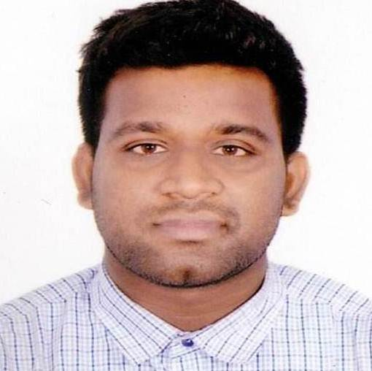
Curriculum Vitae
MD. JUBAYED
C/O: Mohammad Abdus Sattar
01 East Goran Khilgaon, Dhaka-1219
Mobile: 01685641321
E-mail: mohammaddjubayed@gmail.com

Objective:

To enter in a well-reputed and established company for an opportunity to grow and eventual take responsibilities.

Highlights:

- Honest, dedicated, hardworking & quick learner
- Dynamic & energetic
- Innovative & creative
- Work effective independently or as part of a team
- Strong customer focus with good interpersonal skills and cultural sense
- Effective in performing brainstorming and forecasting tasks
- Good communication skill and adaptable

Professional History:
Company Name : BRAC
Position : Program Organizer (IDP)
Period : May 2019 to Continuing

Major Responsibilities:

- Forming Of VDO identifying programme participants, building VDO members capacity for leadership development and leading community for addressing both social and economic issues.
- Organizing group meeting and mobilizing community for identifying different local resources.
- Understanding and implementing different programme components (five to ten) through and integrated innovation approach
- Arranging and conducting community level capacity development different training sessions (gender awareness & sensitivity, communication leadership, enterprise development etc.)
- Ensuring quality of services such as Health, WASH, Agriculture, Education support, UPG, Microfinance, HRLS, Gender awareness and community empowerment through home visit and community meeting.
- Accelerating social mobilization and engaging community people in different development activities.
- Prepare monthly MIS, case studies, learning, challenges and submitting to ADC

Company Name : Nilet Corporation ltd.
Position : Program Officer
Period : April 2017 to March 2019

Major Responsibilities:

- Represent company brand in industry conferences, meetings and workshops
- Manage and monitor grants and prepare funding reports.
- Type Identify and contact new program partners for business expansion.
- Plan and execute program activities in timely and accurate manner.
- Prepare meeting agenda, organize meetings and distribute minutes.

Educational Attainments:

Passed M.A from University of Dhaka in 2017
with. 2.84 out of 4.00

Passed B.A (Hon’s) from University of Dhaka in 2016
with. 2.93 out of 4.00

Passed Higher Secondary School Certificate from Motijheel Govt. Boys’ High School College under Dhaka Board in 2012 [Science Group] with GPA 4.50 out of 5.00

Passed Secondary School Certificate from Motijheel Govt. Boys’ High School under Dhaka Board in 2010 [Science Group] with GPA 5.00 out of 5.00

Training :
Duration - 2 weeks

Statistical Data Analysis
Institute Of Statistical Research and Training (ISRT)
University Of Dhaka

Interest and Hobbies:

- Listening music, Watching debates, Seminar & Discussions on Development issues.
- Playing Games, Computer Games, Watching & Organizing Games. Traveling, Friendship, Work in Computer.

Computer and Language Skills:

- Skillful with MS Office suite, internet navigation and electronic correspondence.
- A good professional proficiency in English (verbal & written).

Commitment:

- Committed to serving the work place sincerely and obediently.
Personal Detail:
▪ | Date of Birth | : June 12, 1995
▪ | Nationality | : Bangladeshi
▪ | Marital Status | : Single

References:

Dr. Mohammad Israfil Md. Mahtabur Rahman
Professor Deputy General Manager
Literature Of Urdu Department Bangladesh Krishi Bank
University Of Dhaka Corporate Branch
Nilkhet, Dhaka BB Road, Narayangonj
Mobile: 01718191747 Mobile: 01716-184652

Declaration of Authority
I do hereby declare that all information have presented are true to my knowledge of required and where applicable this document can be supported by appropriate authentic certificates/paper.

Signature with date


(MD. JUBAYED)

