Curriculum Vitae
of
Md. Jaber Uddin Chowdhury

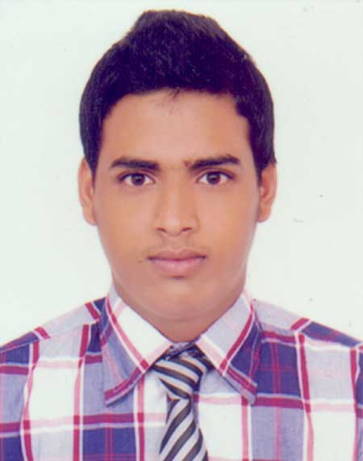

Mailing Address:
Md. Jaber Uddin Chowdhury
Surovi-21, Rajpara, Tilagor, Sylhet.
Mobile No:+8801621925402
E-mail:cjaber9999@gmail.com

OBJECTIVE

Facing challenges of working under any kind of circumstances and working hard efficiently & effectively in order to improve & increase my skills and knowledge I have acquired so far.

EDUCATIONAL QUALIFICATION

B.S.S (Hon’s) in Economics

National University
M.C.College, Sylhet.
Passing Year: 2017
CGPA: 2.83 out of 4.00

Higher Secondary Certificate, Board Sylhet

Group: Humanities
Aushkandi R.P. High School & College
Passing Year: 2012
GPA:4.70out of 5.00

Secondary School Certificate,Board Sylhet

Group: Humanities
Aushkandi R.P. High School & College
Passing Year: 2010
GPA: 4.75 out of 5.00

TECHNICAL SKILLS & KNOWLEDGES

Technical Skills:

- Operating System:Ms – Word, Ms – Excel, Ms – Power Point, basic
Programming concept using Visual basic and internet & E-mail.

Languages Skills:
- Proficient in reading, writing and speaking Bengali.
- Efficient in reading, writing and speaking English as a second language.

PERSONAL INFORMATION

Name :Md. Jaber Uddin Chowdhury
Father’s Name : Md. Elias Uddin Chowdhury
Mother’s Name : Selina Aktar Chowdhuy
Permanent Address : Vill: Amukuna, P.O: A.K. Hiragonj,
Upazilla: Nobigonj, Dist: Habigonj
Religion : Islam
Date of Birth : 1st October, 1993
Sex : Male
Blood Group : B+
Marital Status : Single
Nationality : Bangladeshi
Contact Number : +8801621925402

REFERENCES
Mohammed Shahub Uddin
Associate Professor
Department ofEconomics
M.C College, Sylhet
Mobile:01846837302

Md. Jaber Uddin Chowdhury

