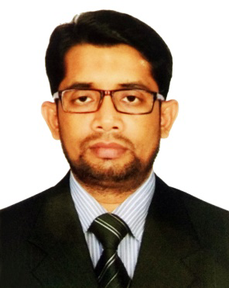
RESUME
of
Md. Jahangir Alam
Cell Phone: +88 01723-353882
Email Address: jahanjiralamru98@gmail.com
CAREER OBJECTIVE:
Looking for hard and challenging job where I will have the scope to utilize my potentiality, creativity and skill to do something innovative and from where I will be able to enhance my knowledge.
ACADEMIC QUALIFICATIONS:
Master of Science (M. Sc)
University : Rajshahi University
Department : Botany
Result : First Class
Year of Passing : 2009

Bachelor of Science (B. Sc Hon’s)
University : Rajshahi University
Department : Botany
Result : Second Class
Year of Passing : 2008

Higher Secondary Certificate (H. S. C.)
Institution : Saidpur Govt. Technical School & College
Board : Rajshahi
Department : Science
Result : Second Division
Year of Passing : 2001

Secondary School Certificate (S. S. C.)
Institution : Saidpur Govt. Technical School & College
Board : Rajshahi
Department : Science
Result : Frist Division
Year of Passing : 1999

COMPUTER SKILL:

MS Office Application, E-mail & Internet Browsing.

LANGUAGE SKILL:

- Bengali (Mother Language)
- English (Speaking, Listening, Writing and Reading ability)

EXPERIENCE:

- I have Seven years experience as SMPO in Glaxosmithkline Bangladesh Ltd.
- I have six months experience as Sr marketing executive in Nutrcia Danone bd Ltd.

PERSONAL PROFILE:

Name : Md. Jahangir Alam
Father’s Name : Late. Zikrul Haque
Mother’s Name : Zubaida Begum
Date of Birth : 1st April 1984
Present Address : Vill: Babrijhar, P.O.: Babrijhar, P.S.: Nilphamari,
Dist: Nilphamari.
Permanent Address : Vill: Babrijhar, P.O.: Babrijhar, P.S.: Nilphamari,
Dist: Nilphamari.
Sex : Male
Marital Status : Married
Nationality : Bangladeshi
Religion : Islam

REFERENCE:

Engr. Md. Enamul Haque  Chief Engineer (Procurement)  DESCO  Mobile: +88 01713-090609  Email: ehaque@desco.org.bd | Dr.Md. Roknuzzman (Rubel)  Registrar(Surgery)  Uttara Adhunik Medical College Hospital  Uttara  Mobile: 01711405730  Email: roknuzzman@gmail.com

I do hereby declare that the above information is true and correct to the best of my knowledge.

Signature
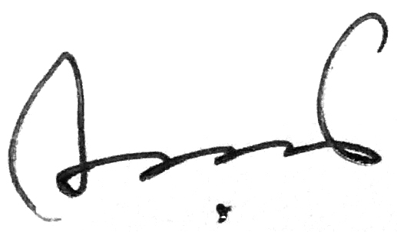

(Md. Jahangir Alam)
- Date: 24/07/2019.

