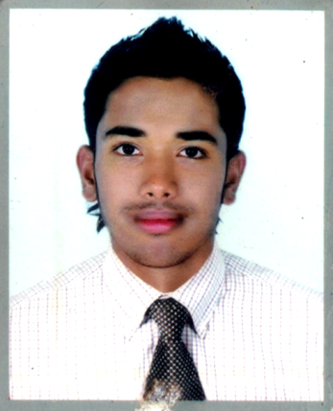
CURRICULAM VITAE

photo
OF

Jahedul Hasan Jahed
Contact: +88 01719 232 189
Career Objective
Aim to work creatively in a competitive a nd challenging working environment with strong responsibility and commitment where job satisfaction and career development will be provided.

Contact Details

Permanent Address : Vill: Niamothpur R/A, South Surma Sylhet -3100.
Personal Particulars
name : Jahedul Hasan Jahed
Father’s name : Md. Khairul Hasan
Mother’s name : Meherun Nesa
Permanent Address : Niamothpur R/A, South Surma, Sylhet-3100.
Date of Birth : 03 Sep 1997
Nationality : Bangladeshi
Religion : Islam
Gender : Male
Blood Group : A+
Marital Status : Single
Email Address : jahed.syl55@gmail.com

Academic Qualification
Certificate/  Exam | Field of study | Name of Institute | Board | Passing Year | Results:  GPA/CGPA
S.S.C | Humanities | MD Mokon High School & College | Sylhet | 2015 | 3.22  (Out of 5)
H.S.C | Commerce | MD Mokon High School & College | Technical Board | 2017 | 4.00  (Out of 5)
B.A.  (Pass) | Bachelor of Arts | Sylhet Govt. College Sylhet | National University | 1st Year Running

Experience : Working as Assistant Manager at Hasan Brother’s since 2014 to till now.

Computer Skills
Have a little bit knowledge about:-
- Microsoft Word.
- Microsoft Excel.
- Microsoft Power Point.

Language skill
Language Spoken Written

Bengali (Native) YES YES
English YES YES
- SIGNATURE
I do here by declare that the above information is true and correctly describes my qualifications and myself to the best of my knowledge.

Date: Jahedul Hasan Jahed

