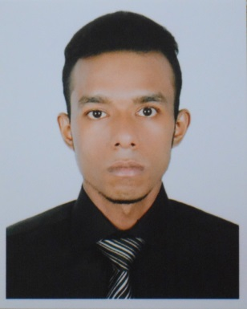

Jahidul Islam Shakil
E-mail: jahidibrahim4@gmail.com
Mobile: 01680086063

CAREER OBJECTIVE:
To build a prospective career in a fast growing private sector enterprise that will help me to develop as a professional and will provide opportunity to improve my skills and knowledge.

EDUCATION QULAFICATION:

Bachelor of Business Administration
Institute : Prime Asia University
Major : Marketing
Minor : HRM
Result : CGPA- 3.00

Higher Secondary Certificate
Institute : Siddheswari Degree College
Group : Business Studies.
Result : GPA- 3.30
Passing Year : 2014

Secondary School Certificate
Institute : Bangladesh Adarsha Shikkha Niketon
Group : Business Studies.
Result : GPA-2.75
Passing Year : 2010

Computer Skills:
    - Microsoft Word, Excel, and Power point
    - Hardware and software
    - Have a good command in online communication and using internet

PERSONAL INFORMATION:

Father’s Name : Jalal Uddin
Mother’s Name : Shahana Begum
Permanent Address : Kalayer Kandi, Comilla, Upazilla: Tatas
Present Address : 112/1 Purbo Rumpura, 1219 Dhaka
Date of Birth : December 15.1994
Gender : Male
Religion : Islam
Height : 5’-7’
Marital Status : Unmarried
Nationality : Bangladeshi

Reference:
S.M. Shahedul Alma
Proctor at Prime Asia University
Email: shahedul1998@gmail.com
Mobile: 01517004829

Shakil
Applicant’s Signature
Jahidul Islam Shakil

