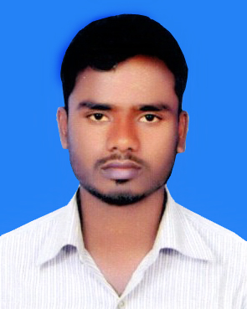

CURRICULUM-VITAE
OF

MD. JUBAYER SAIFULLAH

RESUME

Mobile: 01730-607019

- Career Objective:

To pursue an achievement oriented and challenging career in a reputed and dynamic organization to utilize skill and experience.The need and appreciates a result oriented professional and also provides the opportunity to explore full potentiality in the service industry.

- Personal Details:

- Name : Md. Jubayer Saifullah
- Father’s Name : Md. Abdul Bari
- Mother’ Name : Shirina Khatun
- Date of Birth :01/01/1996
- Nationality : Bangladeshi (By Birth)
- Sex : Male
- Marital Status : Unmarried
- Height : 5 ft 4 inch
- Weight : 56 kg.
- Blood Group : O(+ve)
- Religion : Islam
- Contact No : 01934-244198
- Present Address:

- Village : Titpur
- Post : Rohimgonj
- Thana : Phulpur
- District : Mymensingh

- Permanent Address:
- Village : Titpur
- Post : Rohimgonj
- Thana : Phulpur
- District : Mymensingh

- Educational Qualification:

- Dakhil/SSC (Secondary School Certificate):

- Name Of Institution : Payari Alim Madrasah
- Group : Humanities
- Board : Madrasah
- Year of Passing : 2011
- GPA : 4.63 (out of 5.00)
- Alim/HSC ( Higher Secondary Certificate):

- Name Of Institution : Payari Alim Madrasah
- Group : Humanities
- Board : Madrasah
- Year of Passing : 2013
- GPA : 4.50 (out of 5.00)

- BSS ( Bachelor of Social Science):
- Name Of Institution : Ananda Mohan Collage
- Board : National University
- Name Of Dept. : Political Science
- Year of Passing : 2017
- GPA : 2.95 (out of 4.00)

- Computer Literacy:

- Package Program : Microsoft Word, Microsoft Excel and
Microsoft Power Point.
- Others : Internet Browsing.

- Language Proficiency:

- English : Expert in Reading, writing and speaking ability.
- Bengali : Speaking skill as Native.

I declare that I will be responsible for any wrong information
provided here.

Date: ...............................
Md. Jubayer Saifullah

