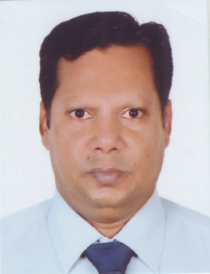
Johny Philip Gomes
Contact no: +8801855808436
+8801847340063
Email: Johnybnb@gmail.com
Career Objective:
To obtain a challenging position in the hospitality industry in which my education & experience can be utilize. Well acquainted in all aspect of pastry cuisine grained from intensive professional experiences can work independently & professionally under any given circumstances in able to work as part of a team.

Key skills | Professional Experiences
- Cake decorations  - Plate garnish  - Variety of bread making  - Intt. dessert making  - Maintain proper hygiene  - Control the cost. | 01.08.2016 to till date  06.06.2011 to 03.06.2014 | American club  Dhaka, Bangladesh  Position: Pastry Chef  Accuro specialist support service  Abu Dhabi, U.A.E  Position: Pastry Chef
Completed Courses  - Essential food safety  A.D.N.H Compass  Abu Dhabi, U.A.E  - Bangladesh parjatan co, Dhaka, Bangladesh  - Baker/Pastry man  Universal Sodexho  Abu Dhabi, U.A.E | 21.09.2008 to 19.12.2010  17.09.2001 to 13.06.2008 | Abu Dhabi National Hotel  Abu Dhabi, U.A.E  Position: Chef-de- Partie  Universal sodexho  Abu Dhabi, U.A.E  Position: Demi chef

Language | Qualifications
English | B.Com (Passed)- 1993
Hindi | Institute: Dhaka University
Arabic | H.S.C-1990
Bengali | Institute: Notredame College
 | S.S.C- 1988
 | Institute: Holy Cross High School

