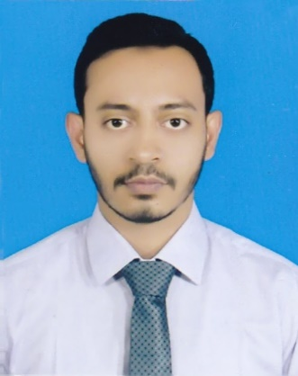
RESUME OF
KAZI MARUFUL ISLAM
C-66, Pathantola, Ward-04, Dhamrai,
Dhamrai Municipality, Dhaka-1350.
Cell: 01689-695939

Career Objective

To employ my knowledge and experience with the intension of securing a professional career with the opportunity for challenges and career advancement, while gaining knowledge of new skills and expertise.

Academic Qualification

Name of the Examination | Group/Subject | Course Duration | Passing year | Name of the Institution | Board/ Affiliated | Division/CGPA
B.Sc in Textile Engineering | Apparel Manufacturing | 4 years | 2019 | Shyamoli textile engineering college | University of Dhaka | 2.95 Out of 4.00
H.S.C | Science | 2 years | 2014 | Jahangirnagar University School and College | Dhaka | 3.90 Out of 5.00
S.S.C | Science | 5 years | 2011 | Dhamrai Hardinge High School. | Dhaka | 4.75 Out of 5.00

Working Experience

2 Month Working Experience at CRESCENT FASHION & DESIGN LIMITED (MEMBER OF THE
BEXIMCO GROUP)

Skills

- Positive attitude,
- Able to work as an active member in a team,
- A good performer in stressful conditions,
- Proactive in nature.

Computer Skills

- Internet Browsing.
- Computer Office Application.
- Email.

Industrial Tour

- Chandra Spinning Mill
- SIM Group
- Ha-Meem Group
Language Proficiency

Language | Reading | Writing | Speaking | Listening
Bengali | Standard | Standard | Standard | Standard
English | Good | Good | Good | Good

Security Clearance

Have no criminal records in any civil court or in any police Station in Bangladesh.

Personal Profile

Name : Kazi Maruful Islam
Father’s Name : Kazi Enamul Haque
Mother’s Name : Dalawara Begum
Permanent Address : C- 66, Pathantola, Ward- 04, Dhamrai,
Dhamrai Municipality, Dhaka-1350.
Religion : Islam
Date of Birth : 24/12/1995
Nationality : Bangladeshi.
Marital Status : Unmarried.
Reference

Shivendra Narayan Shukla  Sr. General Manager  Head Of Factory  CRESCENT FASHION & DESIGN LIMITED (LEVEL-1)  (MEMBER OF THE BEXIMCO GROUP)  Contact No: 01755-587936  E-mail:s.shukla@beximtex.com | Anjum Hanif  General Manager  Weaving  Bangladesh Export Import Company Ltd.  (Textile & Apparel Division)  Contact No:01732-872518  E-mail: anjum@beximtex.com

I hereby declare that the above mentioned statements are true to the best of my knowledge.

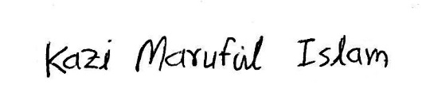
Signature:

Date: 21/03/2019

