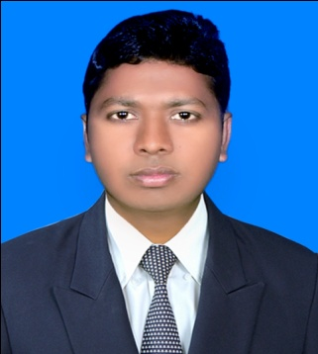
Curriculum Vitae

Kabir
Contact: +8801922-611705
E-mail: hr.kabir2014@gmail.com

Career Objective |  |  | - To build up career in the field where my competency can be developed.  - To choose a career that involves challenges and opportunity for self development.  - To be hard working.  - Willing to utilize conceptual and analytical skills to purse a long term care in organization to convey personal gratification.
Academic Achievements |  |  |  | Masters of Business Studies (Accounting)  Result : 2nd Class  Year of passing : 2013  Institution : AnandaMohanCollege, Mymensingh.  University : NationalUniversity  Bachelor of Business Studies (Accounting)  Result : 2nd Class  Year of passing : 2012  Institution : AnandaMohanCollege, Mymensingh  University : NationalUniversity  Higher Secondary Certificate (Business Studies)  Result : GPA- 3.64  Year of passing : 2007  Institution : Mymensingh Govt. Commercial  Institute,Mymensingh  Board : Dhaka  Secondary School Certificate (Science)  Result : GPA- 2.75  Year of passing : 2005  Institution : FazlulHaqAdarsha High School,Gafargaon.  Board : Dhaka
Computer Literacy |  |  |  | - Operating System : Win.-Xp, Win-7,8,10  - Package : MS Word, MS. Excel, MS. Power Point.  - Others : Internet Browsing, E-mail
Language Skill |  |  |  | Language | Writing | Reading | Listening | Speaking
 |  |  |  | Bangla | Excellent | Excellent | Excellent | Excellent
 |  |  |  | English | Excellent | Excellent | Good | Good
Personal Information |  |  | Father’s Name : TomizUddin  Mother’s Name : MalekaKhatun  Date of Birth : 5th September, 1988  Nationality : Bangladeshi  Place of Birth : Mymensingh  Religion : Islam (Sunni)  Blood Group : A+ (A positive)  Marital Status : Unmarried  Sex : Male  Height : 5 Feet 6 inch  National ID : 6112275035420
Permanent address |  |  | Village : Latuail, P.O. : Mokhi, Upazila : Gafargoan,  District : Mymensingh
Present address |  |  | Village : Lautail, P.O: Mokhi, Upazila : Gafargoan,  District : Mymensingh
Extra Curriculum Activities |  |  | Personal Activities :  - Able to work under challenging environment  - Sincere and eager to learn  - Willing to work in team  - Self-confident & positive minder.  - Commitment to work for positive social change  - Would like to demonstrate potential leadership.  - Love to truest others.
Reference: |  |  | Md.Repon Mia  Executive Engineering Department  Square Fashion Ltd.  (SFL FU-01 Power Gouse)  Mobile:01946223736
Reference: |  |  | A. K. M. Kamruzzaman  A.G.M Janata Bank Limited,  Divisional Office Mymensingh.  Mobile: 01787-762998
Declaration |  |  | I am under signed kabir date of 5 September, 1988 by Nationality Bangladeshi do hereby Cheerfully declaring and confirming that the above statement are true and correct and I will be abide by all confirming that the above statement are true and correct and I will be abide by all conditions furnished and ordered by employer.

Signature

Kabir
Date: 16-11-2017

