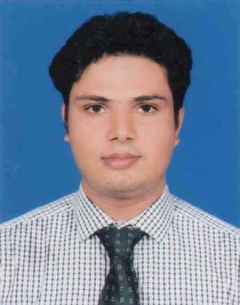
Resume
Of
Md. Kamal Hossain

Address
Moni Kanchun Mallika Abishik Area,
20/2, 20/3, Milkvita Road,
Section-7, Pallabi, Dhaka-1216
Cell Phone: 01747424947
E-Mail: sojolk00@gmail.com

To build up a happy prosper life for the distressed and community people living in the rural and urban community to empower and assist them in initiate their self-reliance thorough strengthen their capacity to enrich them in the issue of decision making life.

B.Sc. (Hon's)
Institution : Bangladesh University of Business & Technology (BUBT)
Subject : Electrical & Electronics Engineering
Group : Engineering
Passing year : Appeared

H.S.C (Higher Secondary Certificate)
Institute : Kaunia College
Group : Science
Result : 3.10
Passing year : 2014
Board : Dinajpur

S.S.C (Secondary School Certificate)
Institute : Kaunia High School
Group : Science
Result : 4.31
Passing year : 2011
Board : Dinajpur

Other Curriculum Activities:
- President, Youth Development Council, UCEP, Mirpur-2, Dhaka

Computer knowledge:
- Operating System : Windows XP, Windows Vista, Windows 7 & Windows 8, Win 10
- Word Processing : Microsoft Word, Excel, PowerPoint.
- Internet Browsing, E-mail Marketing, Basic SEO, Communication System.

Communication Skills:
- Good Communication skill including tact and diplomacy with others.
- Term work has involved difference roles which develop negotiation and persuasive skills.
- Workshop on Analytical Modelling of Optoelectronic Device: A Solar cell Application.
- Has been appreciated for his contribution as a participant in the “workshop on PCB Designing and Prototyping”

Language:

Bangla | Good at speaking and writing in both
English | Good at speaking and writing in both

Personal Information's:
Name : Md. Kamal Hossain
Father's Name : Md. Abdur Rahman
Mother's Name : Most. Josna Begum
Permanent Address : Vill.-Taluk Shahbas, P.O.-Kaunia,
P.S.- Kaunia, Dist.-Rangpur
Present Address : House # 36, Road # 19,
Rupnagar R/A, Mirpur, Dhaka-1216.
Date of Birth : 31-12-1996
Sex : Male
Marital Status : Single
Nationality : Bangladeshi (By birth)
Religion : Islam
Blood Group : B+ positive.

I am confident enough to my knowledge, analytical ability and interpersonal skills, I believe that I will be able to show optimum level of performance in multicultural as well as stressful environment, I would be appreciated if you give me an opportunity to work with you and to executive myself with your support all the information provided here with correct and complete.

Reference:
Reference 1 | Reference 2
Md. Tariqul Islam  Organization: Sonali Bank Ltd .  Designation: Officer Cash  Phone: 01723279733 | Md.Jahangir Alam Pathan  Organization: Pubali Bank Ltd  Designation: Joniur Officer  (Joint Secretary General)  Phone: 01715119154

(Signature)

