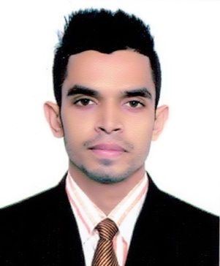
Curriculum Vitae

Photo
Of
Khaled Ahmed
Silam, South Surma
Sylhet- 3100.
Cell: 01630-461212
E-mail: ahmedshopon552@gmail.com

Objective
Objective Career

To obtain a responsible position through which I can utilize my knowledge, enhance my skills as well as can acquire the ability to face a high level of challenges, and get myself provided with varied experience and at the same time I would like to contribute by best to the organization.

Educational Qualifications

Bachelor of Business Administration (BBA):

Name of Institution : Metropolitan University, Sylhet.
Result : Above 2.56 (Out of 4 Scale)
Passing Year : 2018

Higher Secondary Certificate (H.S.C):

Group : Business Studies
Passing Year : 2013
Result : GPA- 3.60 (Out of 5 Scale)
Institution : Dakshin Surma College, Sylhet.
Board : Sylhet.

Secondary School Certificate (S.S.C):

Group : Humanities
Passing Year : 2011
Result : GPA- 4.13 (Out of 5 Scale)
Institution : Silam P.L High School, Sylhet.
Board : Sylhet.

Computer Knowledge

- Able to prepare any type of documents with MS word & Excel
- Able to prepare any type of slide with MS PowerPoint
- Having knowledge on Internet browsing and e-mail, corresponding.

Self Assessment

- Strong desires for leading an honest life with dignity
- Aspiration to build a career showing superior performance
- Energetic, Sincere, Hard working, Honest and Dutiful
- Able to work at any time at any place
- Ability to work as an effective team member

Language Proficiency

- Bengali: Good communication & presentation skills in Bengali as a native speaker
- English: Good communication & presentation skills in English as a second language

Interests & Hobbies

- Traveling
- Discovering new thing
- Communicating with people

Personal Details

Father’s Name : Sultan Miah
Mother’s Name : Saleha Begum
Date of Birth : 10th July, 1994
Permanent Address : Vill. Silam Dalipara, P.O. Choker Bazar
P.S. South Surma, Dist. Sylhet.
Present Address : As Above.
Marital Status : Single
Nationality : Bangladeshi
Gender : Male
Religion : Islam
Blood Group : B+ (ve)

Proclamation
Hereby, I declare that all information stated here is true to the best of my concern.

_____________________________

Khaled Ahmed
Date: -----------------------------------

