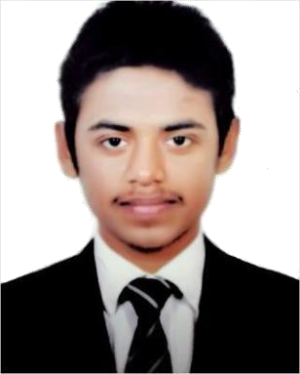

Khaled Hussan Saifullah

House -20(5th Floor), Road- 1/A,Sector-12,

Uttara, Dhaka-1230
Mobile:+88 01789898263
Email: saifullahkhaled68@gmail.com

Career Objective

To serve a responsible administrative position at a well-structured organization & successfully apply acquired managerial& interpersonal skills to enhance organizational efficiencies.

Education

- Diploma in Multimedia Applications Leading to bachelor
Group : IT
Result : Appeared
Year of passing : 2019
Board : Malaysia

- Secondary School Certificate: (SSC)
Group : Commerce
Result : 3.19 out of 5.00
Year of passing : 2012
Board : Dhaka

Computer Literacy

Microsoft word, Microsoft excel, & E-mail Internet.

Personal Abilities

- Proven ability to work effectively & efficiently in both independent & team situation with positive result.
- Excellent communication, interpersonal, research/analysis & leadership skill.
- Strong sense of initiative.
- Energetic & Self-motivated team player.
- Ability to manage stresses & operates under pressure.
- Quick learner and able to grasp new ideas, concepts & methods.

Language proficiency

Bangla - Mother Tongue
English: Fluent both in speaking & writing

Personal Deatils

Name : Khaled Hussan Saifullah

Father’s name : Md. Monir Hussain

Mother’s name : Shahsun Nahar

Cell No. : +88 01789898263

Sex : Male

Date of Birth : 10th September, 1996

Marital Status : Single

Religion : Islam

Nationality : Bangladeshi

Blood Group : O+

Permanent Address : House- 20, Road- 1/A,

Sector- 12, Uttara, Dhaka- 1230

Present Address : ka-65, 15/B, Kha para,

Khilkhet, Dhaka

Experience

Taskeater Bangladesh Ltd.
Designation - Analyst
(From 1st August 2017 - 5th January 2018)

Reference

Imtiaz Ahmed
Manager, Human Resources,Taskeater Bangladesh Ltd.
+88 01717218333
Imtiaz.ahmed@taskeater.com

…………………………
Khaled Hussan Saifullah
Date:

