  - Curriculum Vitae
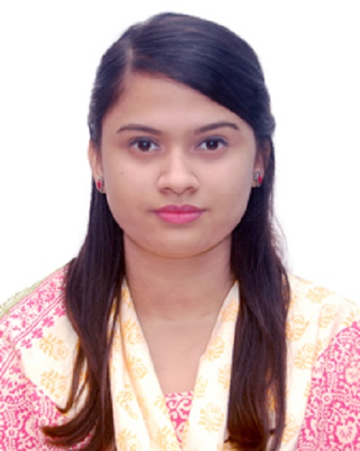
  - Of
FARZANA ALI LABONY
Address: Shaplabag Tilagor, Sylhet
E-mail: Labonyfarzana@gmail.com
Mobile: +88 01759938112
Career  Objective | To build up career through effective communication and dedication making with organization that provides challenging rewarding environment . Added that to use my skills and experience that I have acquired in my education life and to dedicate my whole effort to achieve the organizational goal.
Education | Bachelor of Computer Science(B.Sc )  Higher Secondary Certificate (H.S.C)  Secondary School Certificate (S.S.C)
  Institution | Leading University, Sylhet.
  Department | CSE
  Result | CGPA-2.86 out of 4.00
  Year of Passing | 2017
  Session | 2013-2017
  Institution | Sylhet Govt. Womens College
  Group | Science
  Result | GPA-3.80 out of 5
  Year of Passing | 2012
  Board | Sylhet
  Institution | Shahjalal Jamea islamia High School & College, Sylhet
  Group | Science
  Result | GPA- 4.81 out of 5
  Year of Passing | 2010
  Board | Sylhet
Skills and Tools | - HTML5,CSS,PHP,MYSQL,BOOTSTRAP,WORDPRESS, MICROSOFT WORD,MICROSOFT POWERPOINT.
Professional  Training | - Completed Web Design/Web programming Course in Sylhet it academy.  - Completed Basic Networking Course.
Project | - Sentimental Analysis news summarization.
Personal  Information | - Father’s Name : MD Abdul Ali  - Mother’s Name : Meher Nika Begum  - Permanent Address : Road No: 3 House No: 9, Shaplabag, Tilagor, Sylhet  - Present Address : Road No: 3 House No: 9,Shaplabag, Tilagor, Sylhet  - Date of Birth : 02/01/1994  - Nationality : Bangladeshi  - Religion : Islam  - Blood Group : A+  - Marital Status : Single
References | Rumel M.S.Rahman Pir  Assistant Professor  Department of Computer science & Engineering,  Leading University  Email: rumelpir@gmail.com  Md. Asaduzzaman Khan  Assistant Professor & Head  Department of Computer science & Engineering,  Leading University  Email: mak@lus.ac.bd

