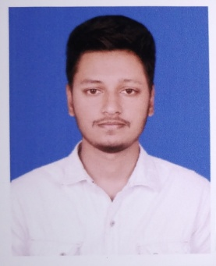
CURRICULUM VITAE OF
MD Limon Hossain
Cell: +8801685727535
E-mail: limonhossain37@gmail.com
Skype: limon.hossain21

- Career Objectives:
To make an excellent career on Computer Technology based on job as an (IT) Engineer. I would like to build an excellent career which has a challenging position and which is rapidly expanding and offers good advancement potential.

- Personal Information:
Name :MD Limon Hossain.
Father’s Name : MD Rafiqul Islam.
Mother’s Name : MOST Moriom Khatun.
Date of Birth : 29-01-1996.
Sex : Male.
Religion : Islam.
Nationality : Bangladeshi (By Birth).
Marital Status : Unmarried.

- Present Address:
C/O :Md. Rafiqul Islam Khilkhet, Nikunja
P.O : Dhaka
Dist : Dhaka
- Permanent Address:
C/O : Md. Rafiqul Islam Vill: Malshapara.
P.O : Sirajganj.
Dist : Sirajganj.

EDUCATIONAL QUALIFICATION

- Secondary School Certificate (S.S.C):

School : B.L Govt High School Sirajganj.
Board : Rajshahi.
Group : Science.
Session :2010-2011.
Passing Year :2012.

    - Result Grade Point: 5.00 (Out of 5)

- Diploma-in-Engineering (4 years)

Institute : Bogra Polytechnic Institute, Bogra
Board : Bangladesh Technical Education Board, Dhaka.
Department :Computer Technology.
Session : 2013-2014.
Passing Year :2017.

    - Result Grade Point: 3.23 (Out of 4).

- Industrial Training and Internship:

- Successfully completed the 3 months industrial training program under the “IT-Q SOLUTION”PANTHAPATH, DHAKA.
- Successfully Completed the 8 week training at “Computer lab” (Bogra Polytechnic Institute, Bogra).
  - Job-Experiences:
- I worked as a junior officer at Zaber and Zubair Fabrics Limited (Noman Group) for 2 Year.
- I worked as an Jr. Executive at JSK Travels for 6 month.

  - Specialization:
- Microsoft Office.
- Computer Troubleshooting
- Computer Hardware.
- Typing Speed 27-30 WPM.
- Best Internet knowledge.
- Graphics Design ( Photoshop CC ).

  - Programming Skill:
- HTML
- CSS
- C

  - Language:
Have an excellent command over English and Bengali languages in both speaking and writing. I know Hindi and Urdu as well.

- Confidence:
I am a smart, young, Energetic, Dynamic, Good-looking an outing pleasant personality and strong personal skill will an ability to work at a high pace on once own Imitative.

- Commitment:
- Committed to hard work.
- Committed to show the honesty & sincerity.
- Committed to proof the job skill & appreciate able personality.
- Reference:

Name : MD. Azizul Aman Al Amin.
Designation : Department Head (Computer Technology) Bogra Polytechnic Institute.
Phone : 01712-685203

- Declaration:

I declare that all the information included here true to my knowledge. If required and where applicable, this document can be supported by appropriate authentic certificates.


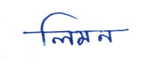
(MD Limon Hossain) Date:

