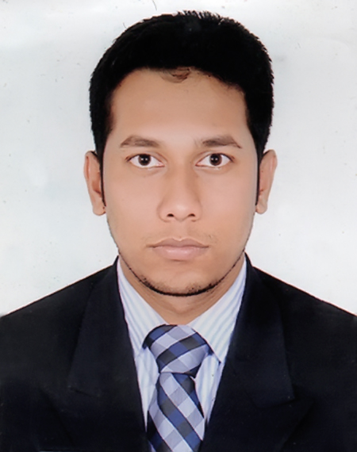
Resume Of
Md. Md Al-Mamun
Address: Uttor norsingpur,Fotullah,Narayangonj.
Cell No: +8801737701557.
Email ID: mamunshaheb57@gmail.com.

Career Objectives
To obtain a challenging position within progressive organization where I can utilize my theoretical and practical experience, technical skillsand I want to build up my career in Textile sector in marketing & merchandising field by the ensuring of buyer satisfaction.

Duties & Responsibilities
Responsible for ensuring the smooth running of the buyer and supplier SOP.
Highly responsible for SMS & Development sample.
Maintaining Production follow up & shipments.
Order follows up by communicating with buyers and suppliers.
All kind of trims booking, Maintaining buyer production file, Tests, Trims.
Interacting with the buyers for any clarifications & getting all approval within the target dates.
Work with internal departments to ensure quality, production and delivery schedule.
Maintain Time & Action plan.

Strength
Proficiency & excellent understanding of Buyer Requirements, sampling, testing, Trims and Accessories.
Able to work under stress with positive attitude and pleasant personality & responsibility.
Excellent team player and willing to take additional job responsibility.
Academic Background:

Qualification | Name of Institution | Board/University | Passing Year | GPA/CGPA
B.Sc In Textile Engineering | Green University of Bangladesh | Green University | 2020 | 2.52 (out of 4)
Diploma in Textile | Khanjahan Ali College Science & technology. | BTEB | 2014 | 3.26 (out of 4)
S.S.C | Kamalpur Secondary School,  Kushtia. | Jessore | 2010 | 3.81 (out of 5)

Computer Summary

System Software (Microsoft Windows 2007, 2010 & XP Operating system).
Application Software (Microsoft Outlook, Office Word, Microsoft Excel, Power Point)
Internet (Advanced internet, All Google app, etc.)

Language

I am very comfort in speaking, listening & writing both in Bengali & English.

Personal Information

Name : Md. Al-Mamun
Father’s Name : Md. Abdul Bari
Mother’s Name : Mst. Sopura Khatun
Permanent Address : Village: Durgapur, P.O: Kamalpur, Thana: Daulatpur, District: Kushtia.
Date of Birth : 04-March-1994.
Nationality : Bangladeshi (By Birth)
Religion : Islam
Marital Status : Unmarried

Co-curricular Activities

Worked as a Volunteer 4th Convocation of GUB.
Organized several programs arranged at school, collage & university.
Ability to work under challenging, stressed conditions and long hours.

References

Professor DR. NITAI CHANDRA SUTRADHAR
Head of the department of Textile Engineering.
Green University of Bangladesh.
Email: nitai@tex.green.edu.bd
Contact: 01713201437

I Md. Al-Mamun, certify that to the best of my knowledge and belief, these data correctly describe my qualifications, my experience, and me.

……………………
(Md. Al-Mamun)

