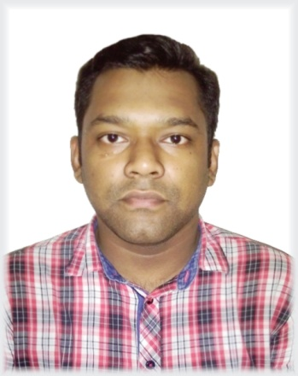
RESUME
Of
MD HAMIM HOSSAIN
Contact Address:
House -30/1(6th Floor),Haji Dil Mohammad Avenue
Block-B,Dhaka Uddayan R/A,Mohammadpur, Dhaka-1207
Cell : 01681258672
E-mail: hamimhossain619@gmail.com

Career Objective

- I have decided to build up my career in the professional field. I would to show my immense aspiration to become a quick learner and to prove myself as a sincere & honest person through extensively hard working and integrity.

Academic Certification

- Bachelor of Science in Electrical and Electronic Engineering (B.Sc.):

    - Institution : Independent University Banlgladesh (IUB)
    - Major : Electrical and Electronic Engineering
    - Minor : Engineering Mathematics
    - Year : 2018
    - Semester : 12th Semester
    - CGPA : 2.62(In a scale of 4.00)

- Higher Secondary Certificate (HSC):

- College : St. Joseph Higher Secondary School
- Board : Dhaka.
- Group : Science
- Year : 2013
- GPA : 3.80 (In a scale of 5.00)

- Secondary School Certificate (SSC):

- School : Mohammadpur Gove. High school
    - Board : Dhaka
    - Group : Science
    - Year : 2011
    - GPA : 4.94 (In a scale of 5.00)

Professional Expression

- A hardworking, self-motivated, self-confident person.
- Strong believer in professionalism & teamwork.
- Strong coordination skills with team building & development aptitude.
- Strong communication and interpersonal skills.

Experience

Organization Name : DESCO
Position : Internship
Duration : 15/09/2018 TO 16/10/2018
Location : Kafrul S&D Division DESCO

Organization Name : AP ( DACCA) Ltd.
Position : Junior Manager ( Electrical)
Duration : 02/12/2018 TO Till Now
Location : Gazipur

Language Proficiency

Bengali (Excellent Reading, Writing & Speaking)
English (Normal Reading, Writing & Speaking)

Computer Literacy

- Proficient in Microsoft Office (MS Word, Excel, Power Point etc.)
- Efficient utilization & applicability of Internet, E-Mail, Skype etc.
- Adept at Type Writing.
- PSIM, PSpice .
- AutoCAD, Proteus .
- MATLAB, LAbView
- Programming Language (C++)

Projects

- Audio manipulation using MATLAB.
- Digital ammeter using PROTEUS.
- Microwave and satellite communication.

Extra Curricular Activities

- Skilled in playing various types of Indoor & Outdoor games.
- Supervised the study tour at School & College.
- Remarkable scholarship I enjoyed while studying at College.
- Volunteer- Volunteer for Bangladesh(VBD), Jaago Foundation, Projonmo 71 and Obhizatrik Foundation.

Area Of Interest

- Power, Energy
- Electronics

Personal Strengths

- Sincere for the assigned work.
- Strong Motivation and commitment for work.
- Capable of adopting in any type of environment.
- Able to work in under pressure.

Personal Information

Name : Md. Hamim Hossain
Father’s Name : Md. Ali Afzal
Mother’s Name : Tahmina Begum
Permanent Address :Village: Chandhodigolia,Post: Chandhodigolia,
Thana+Distric:Gopalgonj
Date of Birth : 25-12-1994
Nationality : Bangladeshi (by birth)
Religion : Islam
Marital Status : Unmarried
Sex : Male
Height : 5′ -4′′

Reference

Navila Rahman Nadi  Lecturer,  Department of Electrical & Electronic Engineering  Independent University Bangladesh (IUB)  Mobile: 01720179200, Email: navila@iub.edu.bd | Md. Enamul Haque  Senior Executive  Digital Marketing, PR & Brand  Ayurvedia Pharmacy (Dacca) Ltd  AP HOUSE |415, North Nayanagor. Dhaka  Mobile: 01922-114141  Telephone:+880-2-9888169,  Email:enamul@apdhaka.com

Declaration

I hereby declare that the above mentioned information is correct.

Md. Hamim Hossain
Date:

