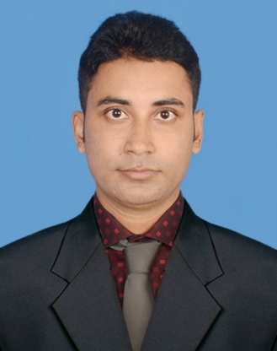
Resume of
Md. Gholam Sarowar
Mobile: +8801740855738
Email: rohansarowar@gmail.com

Career Objective
Looking for hard and challenging job where I will have the scope to utilize my potentiality, creativity, adaptability and skill to do something innovative and from where I will be able to enhance my knowledge.
Education Qualification
Degree | Institution | Discipline | Board | Passing Year | Result
EMBA  MA  BA | Rajshahi University  Rajshahi University  Rajshahi University | Marketing  Language  Language | Rajshahi  Rajshahi  Rajshahi | 2019  2018  2016 | 3.36(Out of 4)  2.89(Out of 4)  3.23(Out of 4)
HSC | Nawabgonj Govt.college | Humanities | Rajshahi | 2011 | 5.00(Out of 5)
SSC | Chataidubi High school | Humanities | Rajshahi | 2009 | 4.19(Out of 5)
Computer Office Application | Glory Computer Training centre, Nawabganj | Bangladesh Technical Education | Dhaka | 2010 | 5.00(Out of 5)

Communication Skills
- Proficiency in oral and written communication both Bengal & English.
- Strong interpersonal skills. Clear, Simple, Easily Understandable and well-arranged Presentation skills.
Computer Skills
- MS Word, Typing speed(English 30 words, Bengali 20 words), MS Excel, MS Power Point, Internet Browsing, PC operating, Software and Hardware knowledge, Multimedia etc.

Skills and Abilities
- Strong, outgoing personality and sense of humor.
- Proven history of reliability, accountability, and responsibility.
- Outstanding communication and problem solving skills.
- Profound openness to gain new knowledge and skills.
Personal Information’s
Name :Md. Gholam Sarowar
Father’s Name : Md. Durul Hoda
Mother’s Name : Mt. Latifa Begum
Permanent Address :Vill: ChayRosia, Post: Islampur, Upzilla: Chapainawabgonj,
Dist: Chapainawabgonj, Division:Rajshahi
Date of Birth :15th August, 1992
Nationality : Bangladeshi (By Birth)
Marital Status : Maried
Sex : Male
Religion : Islam
Blood Group : A^{(+ve)}
Height : 5.4”
Interest : Fishing, Travelling, watching football and cricket…..

Reference
Prof. Shib Shankar Roy
Department of Marketing
Faculty of Business Studies
University of Rajshahi
Contact No-01711 283440
To the best of my knowledge the above mentioned information is true and I am aware about the fact that any misrepresentation of information might be treated as disqualification for me.

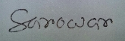
(Md. Gholam Sarowar)

s

