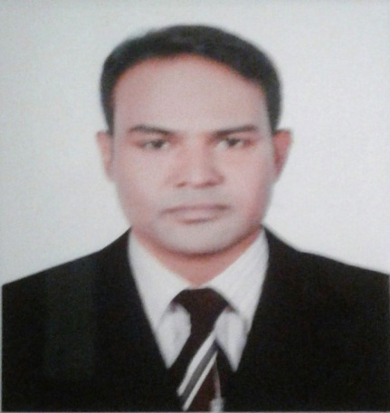
CURRICULAM VITAE
MD. LUTFAR RAHMAN
Cell-01737-988578
Email: lutfarrahman3386@gmail.com

Career Objective
Intend to work in challenging and competitive where strong sense of responsibility and commitment requires where dignity of work provides job satisfaction and the place of work provide s potential avenues for learning.

EDUCATIONAL QUALIFICATION

Masters of Business Studies (MBS)
Name of Institution | : | Kurigram Govt. College, Kurigram
Board | : | National University
Major Subject | : | Management
Result | : | 2nd Class
Year of Passing | : | 2009

Bachelor of Business Studies(4 years) B.B.S
Name of Institution | : | Kurigram Govt. College, Kurigram
Board | : | National University
Major Subject | : | Management
Result | : | 2nd Class
Year of Passing | : | 2008

Higher Secondary Certificate (HSC)
Name of Institution | : | Rajarhat Karigori Banijjik College, Kurigram
Board | : | Dhaka
Result | : | 3.82(Out of 5.00)
Group | : | Business Management
Year of Passing | : | 2004

Secondary School Certificate (SSC)
Name of Institution | : | Monidakua Dakhil Madrasha, Kurigram
Board | : | Dhaka
Result | : | 3.67(Out of 5.00)
Group | : | Humanities
Year of Passing | : | 2002

Computer Literacy
- Computer Application Course (MS Word, MS Excel, MS Access & MS Power Point).
- Operating Online Network including e-mail & internet.

Language Proficiency
- Bengali (Mother Language) : Fluent in Reading, Writing and Speaking.
- English : Fluent in Reading, Writing and Speaking .

Working Experince
- Seven Years Job Experince, DA, RMS The Nielsen Company Bangladesh Ltd.
- Honest and punctual.
- Quick Learner.
- Like to take challenges.
- Amiable and Friendly.
- Adaptive to any environment.

Personal details
Name | : | Md. Lutfar Rahman
Father's Name | : | Late. Abdul Jalil
Mother's Name | : | Latifunnesa
Date of Birth | : | 03-03-1986
Nationality | : | Bangladeshi
Marital Status | : | Married
Gender | : | Male
Blood Group | : | O+
National ID No. | : | 3257645568
Religion | : | Islam
Present & Permanent Address | : | Vill:-Munshi Para, P/O:- Daldolia, P/S;- Ulipur, Dist:-Kurigram.

Reference
1.Md. Goljar Hossain  Sr. Executive  DA, RMS  The Nielsen Company Bangladesh Ltd  Mob. 01711-486666 | 2. Md. Shajahan Mia  Manager  DA, RMS  The Nielsen Company Bangladesh Ltd  Mob. 01711-102686

Declaration
I declare that all the information’s presented here are true and if required and where applicable, these documents can be supported by authentic certificate.

_________________________
(Md. Lutfar Rahman) Date:

