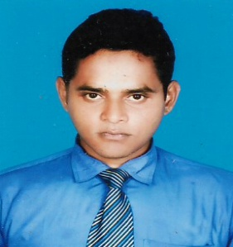
MD. MOHAIMINUL ISLAM
E-mail: mohaiminulalh@gmail.com
Mobile: 01750-736920

RESUME
OF
MD. MOHAIMINUL ISLAM

Career Objective
To pursue a challenging career in a Organization where I can devote my full effort to achieve the goal of the company, to take the job with a great sense of responsible, to enjoy the challenge of new situation an to be expert to make a positive contribution to the position.

Profile
I am sincere, honest, obedience and hard working person. I know how to encourage other person to complete work perfectly. I can work at any situation. I have excellent organizing capability.

Education and Qualification

- Secondary School Certificate (S.S.C)

- Institute : Rangpur High School
- Group : Science
- Passing Year : 2006
- Board : Rajshahi
- Result : 4.25 (Out of 5)

- Higher Secondary College Certificate (H.S.C)

- Institute : Collectorate School & College Rangpur.
- Group : Business Studies
- Passing Year : 2008
Board : Rajshahi
- Result : 3.70 (Out of 5).

Computer Skill: Microsoft – Word, Ms. Excel, Internet Browsing & Etc.

Language Skills
Bangla (Fluently), English (Communicative)
Experience :3 years experience in RFL Group of companies as a Sales Representative.

Personal Information

- Name :Md. Mohaiminul Islam.
- Father’s Name : Md. Rezaul Islam.
- Mother’s Name : Most. Momotaj Begum.
- Sex : Male.
- Date of Birth : 09/08/1991.
- Marital Status : Unmarried.
- Nationality : Bangladeshi. (By Birth)
- NID No : 9555075879.
Religion : Islam (Sunni).
- Blood Group : B+(positive).
- Height : 5′-6″.
- Cell No : 01750-736920.

Permanent Address

Vill:- Bholar dighi, Kamarpara.
P.O.- Babukha.
P.S.- Kotowali.
Dist- Rangpur.

Present Address

Vill:- Bholar dighi, Kamarpara.
P.O.- Babukha.
P.S.- Kotowali.
Dist- Rangpur.

Given the qualification that I have attend so far I humble place myself as an aspirant of the job in question and assure your kind self that will try my best of prove my competence, efficiency and professionalism in this regard.

I certify that the information, which are furnished above are true to my knowledge. Hoping for a quick and positive responsibility.

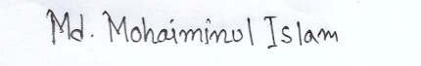
Signature

Md.Mohaiminul Islam.

