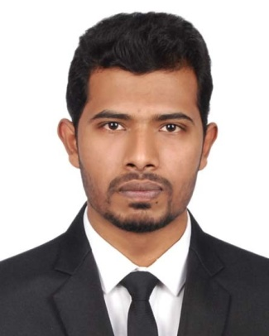
CURRICULAM VITAE
OF
MD. MOKTADIUR RAHMAN
3-A, 285, Elephant Road, Dhaka-1205
Mobile: +8801723517783
E-mail: moktadiurrahman94@gmail.com

Carrier Objective:
To achieve a challenging positions that will provide future opportunities for growth and a change to my skill that acquired from my education .To make use of my interpersonal skills to achieve goals of a company that focuses on customer satisfaction and customer experience.

Educational Qualification:
B.Sc. in Electrical and Electronic Engineering (EEE):
Institute : Daffodil International University
CGPA : 2.79
Session : 2015-2018
Year of passing : 2019

Higher Secondary Certificate (H.S.C):
Institute : Sara Marwari High School & College, Ishurdi, pabna
Group : Science
Board : Rajsahi
GPA : 4.00
Session : 2012-13
Year of passing : 2014

Secondary School Certificate (S.S.C):
Institute : Bansharbada M.L high school, Ishurdi, pabna
Group : Science
Board : Rajsahi
GPA : 4.25
Session : 2011-12
Year of passing : 2012

Computer Literacy:
- Application: MS Word, MS Excel, MS PowerPoint
• Software: AutoCAD, Matlab, Proteus
- Expert using Pos & SAP software
- Type : Bengali & English

Tanning:
- Practical SEO ( BITM)

Extra Skill:
- On-page SEO
- Off-page SEO
- Keyword research
- Image optimization

Job Experience:
- Fresher

Language proficiency:
- Bengali: Bengali Mother Language
- English: Excellent communication skills in English

Strengths:
- Able to communicate with people and to work with all types of personalities
- Flexible and to work well both individually and team
- Good in handing stress, working under pressure and meeting the deadlines positively

Interest & Hobby:
- Electrical & Electronic project work
- Sports , Walking, Exercise ,Swimming

Personal Information:
Name : Md. Moktadiur rahman
Father’s name : Md. Ali Ahsan
Mother’s name : Taslima Khatun
Permanent Address : Village: Chor Kodimpara, Post: Digha-6622, P/S: Ishurdi,
District: Pabna, Division: Rajsahi
Date of birth : 10.11.1997
Religion : Islam
Nationality : Bangladeshi
Marital status : single
Sex : Male
Blood Group : A+

Reference:
Dr. Md. Rezwanul Ahsan
Assistant Professor
Department of Electrical & Electronic Engineering
Daffodil international university
Email: ahsan.eee@diu.edu.bd
Phone NO: +8801712-599409

Declaration:
I, the undersigned, declare that to the best of my knowledge and belief, the information given in this curriculum vitae is true, complete and accurate.

Signature
Date:

