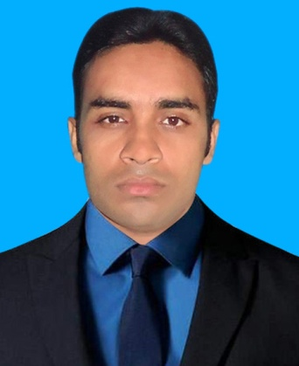
RESUME
OF
Md. MONAEM

MD.Monaem
Vill- NoakhaliMouja, P/O- Pak- kishorgonj,
P/S- Sadar, Dist- Noakhali.
Mobile: (+) 88 01811-137303; (+) 88 01814-989930
Email: haque.md115@gmail.com

Career Objective

To obtain a reasonable and challenging position where I can apply me academic knowledge, creativity and experience in to practical field that offers opportunity for a career in an attractive environment and to be expert in the field of community health. Sector and serve my country as well as my community.

WHAT`S MAKE ME DIFFERENT

I am an honest, intelligent, diligent, and ready to go the extra lack to achieve the target. I have set for my-self. I can lead and be lead, as situation requires. I am and optimist by nature and have a good sense of homer. I want to perform my duties in time. I am disciplined.

Academic Qualification

Degree | Year of Passing | Institution/Board | Subject/Department | Result/Grade
LL.M | 2018 | Southern University Bangladesh,Chittagong. | Law | 3.00 (Out of 4)
LL.B | 2015 | University Of information Technology & Sciences | Law | 2.79 (Out of 4)
HSC | 2010 | Sonapur Degree College | Humanities | 2.50 (Out of 5)
SSC | 2007 | Ahamodia Adarsha High School | Humanities | 3.00 (Out of 5)

PROFESSIONAL EXPERIENCE

- Computer Skill on office management
- Internet & E-mail.
- Apparel Merchandising (Chittagong BGMEA Institute Of fashion & Technology) Batch No-101, ID-031-2650-340
- 2016 to 2017 one year Work Experience In Quality Department as Table QA, Process QA & Getup QA at Modiste Bangladesh Ltd.
- 2018 to 2019 one year Work Experience In Quality Department as Line Quality at Farzana Fashion world ltd.
- I have Experience on all kind of Knit & Woven item like Men’s/Boys/Ladies/Kids Tee shirt, Polo Shirt, Pajama set, Hoody, Jogger, Casual Shirts, Shorts & Denim pants.

Language Proficiency

Language | Reading | Writing | Speaking
English | High | High | Medium
Bengali | High | High | High

Personal Information

- Father’s Name : Md. Masudul Haque
- Mother’s Name : Nazma Begum
- Date of Birth : 03 Martch1991
- Nationality : Bangladeshi (by birth)
- Marital Status : Single
- Blood Group : o+
- Religion : Islam
- Present Address : 3 No. Rail gate, Pahartali, Chittagong.
- Permanent Address : Vill- NoakhaliMouja, P/O- Pak-kishorgonj,
P/S- Sadar, Dist- Noakhali.
- Contact Number : 01811-137303
_______
Signature
Md. Monaem

