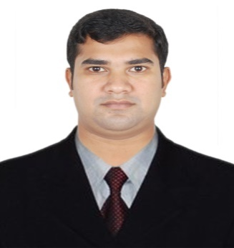
CURRICULUM VITAE
OF
MD. SHOHIDUL ISLAM
Mobile No: 01705-629470
Email: shohidul11civil@gmail.com

Career Objective:

To make positive contribution as part of your dynamic and well reputed organization in a position where my abilities, technical, management decision making and communication skill will be utilized and enhanced with the specialized knowledge of Civil engineering

Education Qualification:

B.SC in Civil Engineering
- Name of the Institute: European University of Bangladesh.
- Subject : Civil
- Year of Examination : 2020
- Result : 3.42 Out of 4.00
Diploma in Civil Engineering
- Name of the Institute: Bangladesh Polytechnic Institute
- Subject : Civil
- Year of Examination : 2016
- Result : 3.20 Out of 4.00
Secondary School Certificate (S.S.C)
- Name of the Institute: Ranihati High School
- Group : Humanities
- Year of Examination : 2011
- Result : 3.75 Out of 5.00
- Board : Rajshah
Experience:
Name of Organization : SRD Limited
Address : House 308, Road -2, Baitul Aman Housing
Society Adabor Dhaka-1207
Designation : Site Engineer
Duration : 2nd December2018 to till now.

Industrial training:
- Building lay-out.
- Pail point lay-out.
- Pail work: Cast in situ.
- Sub-structure.
- Super structure.
- Civil work, Brick work Plaster work, Door frame &Grill Fitting.
- Plumbing work.
- Electrical work
- Tiles work.
- Painting work.
- Thai Aluminum Fabrication.
- Project Documentation.
Computer Skill:
- Operating system windows XP, windows7, and windows8.
- Microsoft office.
- Internet: E-mail & Internet Browsing.

Language Proficiency

- English: Have-fluency in Writing, Reading, and Speaking & Listening.
- Bengali Mother Tongue.

My Belief:
- I can do my job effectively and efficiently. My job always time responsibilities.

Personal Information

- Name :Md. Shohidul Islam
- Fathers Name : Md. MahatabUddin
- Mothers Name : Mst. Rani Begum
- Present Address : 37/11, JahuriMohalla, Ring Road,
Shyamoli, Dhaka-1207.
- Permanent Address : Vill: Ranihati, PO: Ranihati,
P.S: Shibgonj, Dist: ChapaiNawabgonj.
- Date of Birth : 1-02-1994
- Marital Status : Single
- Sex : Male
- Nationality : Bangladeshi (By Birth)
- Religion : Islam
- Height : 5’-6’’
- Blood Group : O+

Declaration:

I Hereby confirm & solemnly declare that the information given above is authentic, complete and correct to the best of my knowledge and belief I am also prepared to submit any additional information/documents if required.

Date: ................................. Signature of Applicant

