
MEHBUB HASAN CHOWDHURY

Address: 2/I/2, Extension Pallabi,Mirpur,Dhaka-1216

Call: +8801688843196
Home Phone: +8801723172384
E-mail:mehbub.h.chowdhury@gmail.com

Objective :

To explore the challenges and opportunities of real business environment and to work alone and with other to achieve personal as well as organization goal with merit, diversity and commitment.

Professional work experiences | :

. | Customer Care Executive (after sales service) at Wood World  ( May 5, 2021 – June 8,2021)
Job Responsibilities
• Motivate the clients about the company products and benefits and maintain good relationship with them
• Giving proper and detailed product information to clients over phone.
•Achieve individual monthly targets to retain company's goal.
• Contributes to team effort by accomplishing related results as needed.
• Regular follow-up with existing / potential clients using software.
• Building relationship with existing and new clients by ensuring proper services.
• Effectively and efficiently handle the operational tasks from the sale Manger.
• Analyze and inspect the market accurately to enhance business growth.
Customer Service Representative at Digicon Technologies Limited
(March 20,2020- September 18,2020)

Job Responsibilities

- Give Customers Service and Client business customers customer through Digital financial service of Bangladesh post office (Nagad).
- Provide excellent customer service and gives precise information to the customers like account opening, benefits by ensure customer satisfaction.
- Identify customer needs ,clarify information and provide solutions like account related problems, frauds, wrong transaction etc.
Perform actively to solve client different query and identify their needs To share knowledge through (social Media ),email &web chat.
Resolved customer grievances and identify for further investigation

Executive (Customer Service Department ) at Walton
( August 1, 2018 - June 24, 2019)

Job Responsibilities

- Customer Relationship Management through Walton website and ecommerce sites
- Find out the customer's needs
- Recommend, select and help locate the right merchandise
- Describe a product's features and benefits
- Answer customer queries regarding the store and the merchandise
- Make suggestions and encourage purchase of products by Walton website and ecommerce sites selected products
- provide information about warranties, manufacturing specifications, care and maintenance of merchandise and delivery option

Officer (Customer Care Department) at NITOL NILOY GROUP
(April 4, 2017 - June 24, 2018)

Job Responsibilities:

- Provide Strategic Leadership of customer care with combined stuff
- Provide one-stop quality Customer Service over phone as well as face to face to ensure positive customer experience.
- To maintain the coordination and professional strong working relationship with external and internal customers, colleagues, and Customer service management.
- Proactively aware/inform customers regarding products/service.
- Sale through inbound and outbound contacts.
- Capture customer insights and escalate critical issues / complaints and provide timely feedback

Officer (Commercial Department ) at Pioneer Apparels Limited
(February 4, 2015 - March 30, 2016)

Job Responsibilities:

- Handling overall cash incentive preparation
- Preparing import and export document
- Communicating with bank, BGMEA, EPB, C&F and other authorities ▪Prepare Quotation, Indent/Performa Invoice.
- Deal with L/C, Shipments and Payments
- Other work/Task/Assignment given by the Management.

Educational Qualification:

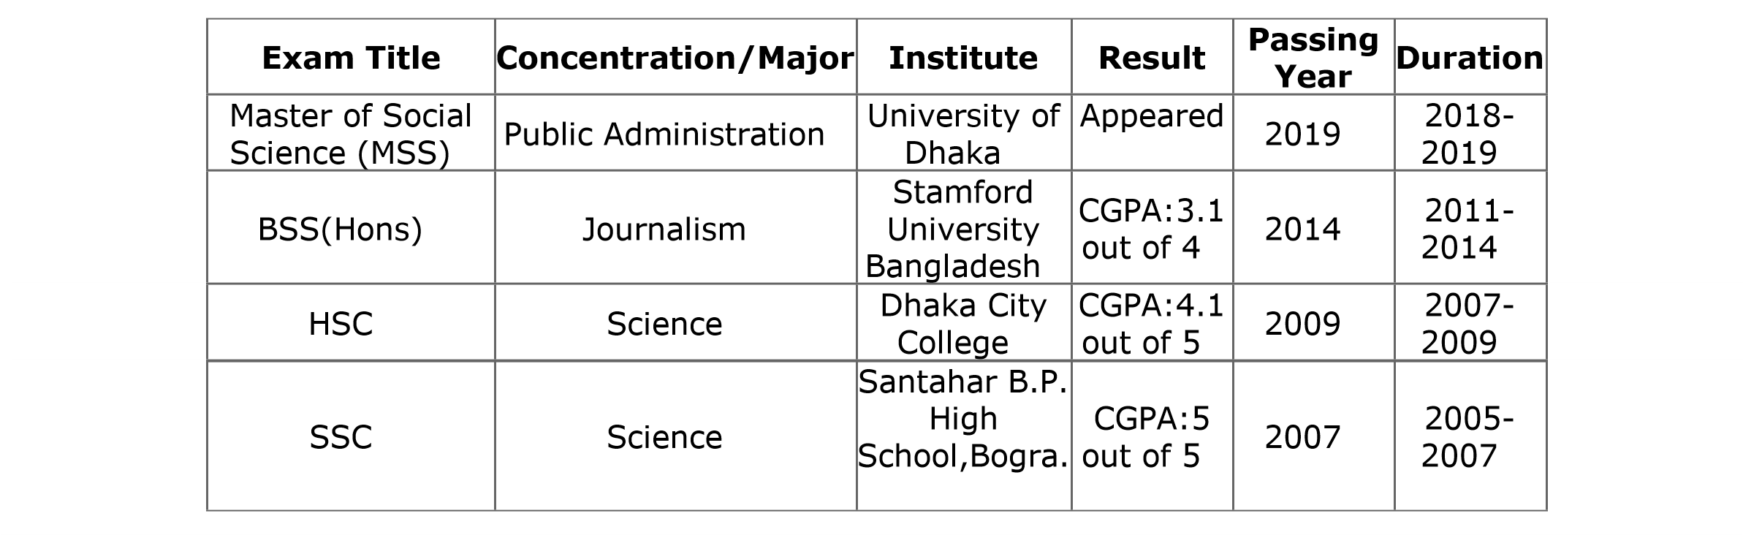

Key Professional skills:

- Advocacy & Networking, Community mobilization, Community Development, Youth advocacy
- Risk Management, Policy analysis
- Sensitivity and respect in diversity

Training and Capacity Building:

National Training & Workshop Received:

SL | Name of the training/ workshop | Duration | Organization | Time/Year
1. | News Reporting and Presentation | 3 Months | Jobsa1.com | 2010
2. | Participated in a day long seminar on CV writing, Interview facing and Adaptation with the job environment entitled “Pathway to Career Development | 1 day | Bdjobs.com | 2015
3. | Communication Skills | 2 day | British Council | 2010
4. | Youth Leaders Training | 4 day | YEH | 2009
5.  6. | Basic Computer Training Course  Search Engine Optimization | 6 Months  3 months | Institute of ICT under SIT – Foundation.  Dimension IT and Software | 2011  2018

Personal Information:
Name | : | Mehbub Hasan Chowdhury
Fathers Name | : | Mahbubul Wadud Chowdhury
Mother’s name | : | Pervin Akhtar
Date Of birth | : | June 15,1991
Sex | : | Male
Marital status | : | Single
Blood Group | : | O+
National ID | : | 7767145621
Passport Number | : | BTO673027
Nationality | : | Bangladeshi
Mailing Address | : | 2/I/2 Extension Pallabi, Mirpur, Dhaka- 1216
Permanent Address : | : | Village: Piyarapur, Post Office: Boyali, Thana:Gaibandha,Zilla: Gaibandha -5700
Personal Interest :

- Reading Articles & novels
- Watching Art films and listening music
- Cricket
- Traveling

Language Proficiency:

Excellently proficient in both English and Bangali (Listening, Reading, writing & speaking).

Computer Skills:

- Basic Hardware, Operating System: Windows 07 and Windows 08, Windows 10
- Application Software: MS Office Suite (Word, Access, Excel, PowerPoint)
- Internet Uses

Name of the References:

Reference 1 | Reference 2 | Reference 3
Mahbub Alam  Major  Bangladesh Army  Head Quarter of Dhaka Cantonment,  Dhaka  Mobile Ph. No:+8801711239563 | Nandita Tabasuum  Professor  University Of Liberal Arts  (ULAB)  Saat Mosjid Road, Dhanmondi-  15,Dhaka  E-mail: tnandita@gmail.com  Mobile Ph.No:01918108619 | Mehetarin Sharmin  Assistant Teacher  Jalalabad Cant. Public School and  College  Sylhet Cantonment, Sylhet  Email:mehetarin.mou@gmail.com Mobile Ph. No-01891759788


Signature: ----------------------
(Mehbub Hasan Chowdhury)

