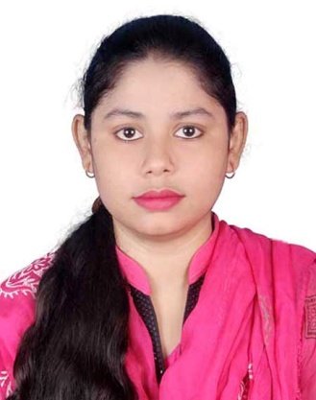
Resume of Mitu Akter
359/1 Jafrabad, poolpar ,
Mohammadpur, Dhaka- 1207.
Cell: 01742745446
E-mail: mituakter.89@gmail.com
Career Objective
Have the greatest desire to deliver maximum possible effort to get things done & strong will to learn as well as a self – motivated person. I have the intention to serve any esteemed organization with utmost sincerity that offers challenges to accomplish mission, to achieve set goals with optimum perfection on the way to build up a career as a professional.
Educational Qualification

- MBA
State University of Bangladesh
Session: 2014
Passing year: 2015
CGPA- 3.77 out of 4.00

- BBA
Mohammadpur Kendriya College (National University)
Major Area: Finance
Passing Year: 2012
CGPA- 3.33 out of 4.00
- Higher Secondary Certificate
Mohammadpur Preparatory Girl’s College
Group: Business Studies
Passing Year: 2006
Board: Dhaka
GPA- 4.10 out of 5.00
- Secondary School Certificate
Ali Hossain Girl’s High School
Group: Business Studies
Passing Year: 2004
Board: Dhaka
GPA- 3.50 out of 5.00

Language Proficiency
- English : Excellent in speaking and writing
- Bengali : Mother tongue
- Japanese Language: N5, N4 and N3 Continue

Work Experience
- Fulkoli Kindergarten
Designation- As a English Teacher (01.01.2016 to 31.07.2018)
- Unik Education Japanese Language School.
Designation - As a Japanese Language Teacher (01.09.2018 to till now)

Self Assessment
I am sincere, honest, hard working, pragmatically challenging, self-motivated and reasonably presentable person having positive attitude towards working with good interpersonal relations with different nationals and religions.

Practical Experience
As a mandatory part of the BBA program, I have completed three-month internship program in Mercantile Bank Limited on Satmosjid Road Branch with and objective to gain practical knowledge on rehabilitation procedure of sick industries.
Computer Skill
- Microsoft Office Package
- Internet Browsing

Personal Profile
Name : Mitu Akter
Father`s Name : Md. Abdul Bari.
Mother`s Name : Rabeya Begum.
Religion : Islam.
Marital Status : Married.
Date of Birth : May 4, 1989.
Nationality : Bangladeshi by Birth.
Permanent Address : Village: Vodua, Post Office: Alamdanga
Police Station: Alamdanga, District: Chuadanga.

The Person who know my ability
Md. Zuglul Pasha Md. Himel
Vice-principal Internal Lecturer
Mohammadpur Kendriya College Mohammadpur Kendriya College
Cell: 01552376940 Cell: 01819192905

Certification

I, the undersigned, certify that to the best of my knowledge and belief, the information given here by describes myself, my qualifications and my experience. I understand that any willful misstatement described here in may lead to my disqualification.

________________
Mitu Akter

