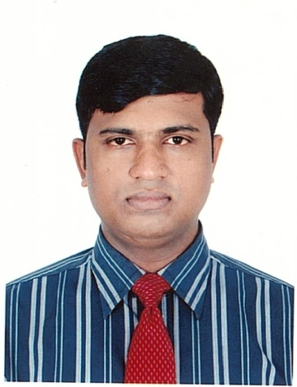

MITU DEY

Subuj bhagicha, block-b, 7

kalibari Road Akhalia Sylhet

E-mail: mitudey078@gmail.com Gender: Male Mobile: 01752420342

Principle Transferable Skills Profile
- Excellent creative innovation and problem solving.
- Highly interdisciplinary including human and technical aspects.
- Excellent interpersonal and organisational skills with a refreshing attitude towards Training
- Self-starter and quick learner who is accustomed to working in a pressurised environment.
- Possessing a good sense of humour and the ability to develop and motivate others.

I have always been a person who is keen to learn and work hard, which I believe to gain further experiences for the job that I do. I use my initiative when required and am able to communicate with people at all levels. If I was given the opportunity I hope to bring value to any organisation through my punctual and hard working outlook.

Working Experience:

Prime Bank Ltd, Job Title: Sales and personal Banking
Upashahar Branch Sylhet, Bangladesh

Duties: - Obtaining and checking of references from referees given by applicants for business
- Opening and maintenance of Business accounts
- Inspection and appraisal of loan cases
- Collection of loan and keeping books of accounts up to date
- Co-operation in decision making
- Dealing with customer queries, ensuring that all customers needs are met and a high standard of service is provided
- Liaising with customers and staff members on a daily basis
- Performing all general administrative duties

East End Logistics
116 Mile End Road
London E1 4UN Job Title: Assistant Manager
Duties:
- Making sure the shop floor runs smoothly
- Meet the store`s monthly targets and handle budgets
- Recruit and train staff
- Deal with any enquires and complaints and monitor customer service
- Serve customers as needed
- Put together rotas and shifts
- Check the product
- Managing deliveries.

Imperial London Hotels
6, Coram Street, London
WC1N 1HA
Job title: Supervisor

Responsibility:

- Welcome guests
- Demonstrating menu Knowledge
- Answering questions
- Up selling specialty items
- Describing dishes
- Taking orders ( beverage and food)
- Ensuring Guest Satisfaction
- Bring out food
- Clearing empty plates
- Refilling drinks
- Bringing extra items requested by guests
- Ensuring the food came out as desired
- Clearing all plates at end of meal
- Crumbing the table
- Offering after dinner drinks and dessert
Cash handling (when processing the check)

Educational Qualification:

1. Master of Business Administration (2014)
Anglia Ruskin University, Cambridge UK

2. Edexcel BTEC Level-7 Extended Diploma in Strategic Management and Leadership (2013)
International school of business studies, Middlesex, UK

3. Master of Science in Mathematics
National University, Bangladesh.
2nd Class.

4. Bachelor of Science in Mathematics
National University, Bangladesh.
2nd Class

5. Higher Secondary Certificate, group in Science.
Sylhet M.C. College, Bangladesh.
2nd Division

6. Secondary School Certificate, Group in Science
Blue Bird High School, Sylhet, Bangladesh.
1st Division

Professional Skills

Computing (IT) ♦Data base Maintenance
♦Good knowledge of MS-Word, MS-Excel,
MS-Power- Point.

Communication ♦Drafting formal reports and presentations
♦Equally able to discuss technical and business details

Interpersonal and ♦Team working skills developed by participating in
Teamwork Project.
♦Capable to organise events and participate seminars.

Business awareness ♦Understanding realities of business
♦Knowledge of sales and marketing
♦Handling office routines efficiently

Work style ♦Working under pressure
♦Meeting deadlines
♦Handling several tasks at once
♦Prioritising task to ensure all are completed on time.

Training
♦Professional Receptionist Training by Pitman Training
♦ Customer Service Training by Holiday Inn
♦ Stay Real Training by IHG

Language
♦ Fluent in English in both spoken and written

Activities
♦Member: Sylhet Friday Club Ltd. (Bangladesh).
♦Member: Rising Star Cricket Club Ltd.

Interests

Food ♦Off weekend, I enjoy meeting with my friends and
Cooking. We do this on a regular basis, and take it in
turns. I enjoy socializing and mixing with others.

Reading ♦When I am trying to relax I enjoy reading, and have
done this throughout my life; I find it helps to develop . Communications skills.

Sports ♦I enjoy a variety of sports in particular Cricket, Football,
Badminton.

Reference:
  - Md. Zillar Rahman
Secretary Ministry of Social Welfare
0209540452
01713277766
Zrahman61@yahoo.com
www.msw.gov.bd

  - DR. Md:Anamul Haque
Lecture comminute medicine division
Sylhet M.A.G Osmani Medical College.
Sylhet-3100
01714109303

