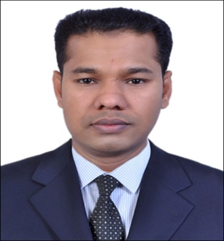
Mohammad Mohibur Rahman
Job Apply for: Security officer/Light Vehicle Driver/Any Suitable Job
Email: mohiburrahman938@gmail.com
Cell No: +971529642676/+8801785917464

CAREER OBJECTIVE:
To purse fulfilling responsible and efficient career orientation in an esteemed organization than can harness my skills and provide me with the environment of invaluable professional training, opportunity and experience essential for my growth.

QUALIFICATION:
- Secondary School Certificate
- Computer Basic Knowledge & CCTV
- First Aid Certificate
- Light UAE Driving License (Manual ) for pass above 4 years

WORK EXPERIENCES:
- Worked as Charhand in Multiforms LLC (Emaar Group) in DIP, Dubai, UAE for 3 years.
- Working as Security Officer with Multiforms LLC (Emaar Group) in DIP, Dubai, UAE for 7 years to till date.
DUTIES & RESPONSIBILITIES:
- Access control & Issuing Contractor & Visitor Passes
- Check all Vehicle moving in & out of the Permission
- Patrolling the premises to check for intruders
- Assisting the guests in locations.

JOB COMPETENCIES:
- Excellent communication skill
- Ability excellent dealing with customer
- Able to lead good role with people
- Able to manage own time and work

PERSONAL DETAILS:
Date of Birth : 10/03/1982
Marital Status: Married
Nationality: Bangladeshi
Passport No: BQ 0617918
Religion : Islam
Gender : Male
Language known: English, Hindi, Arabic & Bangle.

Declaration:
I hereby declare that the above mentioned statement is correct & true to the best of my knowledge & belief.

