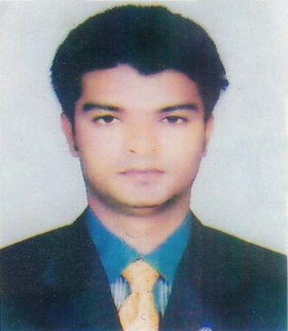Curriculum Vitae of
MD. MONIRUZZAMAN TALUKDAR

MAILING ADDRESS :

Vill: Kaigati, P/O: Niamotia, P/S: Dhunat, Dist: Bogra
Mobile: 01750-404886, E-mail: monirtalukder87@gmail.com

CAREER OBJECTIVES
To attain a job as a position which will allow me to apply my knowledge and facilitate me to gain knowledge to the real implications of the business world as well as to prove my potentiality through hand work and efficiency.

EDUCATIONAL QUALIFICATION
- Master of Business Studies (MBS) Applied
University : National University
Institution : Govt. Azizul Haque Collage, Bogra
Result :
Passing year :
- Bachelor of Business Studies (BBS)
University : National University
Institution : Govt. Shah Sultan collage, Bogra
Result : 2nd Class
Passing year : 2009
- Higher Secondary Certificate (HSC)
Institution : Joylajuyan College,Sherpur,Bogra
Group : Business Studies
Result : G.P.A- 3.10
Board : Rajshahi Board
Passing year : 2005
- Secondary School Certificate (SSC)
Institution : Ruddrobaria Bilpathia High School,Dhunat,Bogra
Group : Business Studies
Result : G.P.A- 2.75
Board : Rajshahi Board
Passing year : 2002

EXPERIENCE
Accountant (Officer 2), EHSAN SOCIETRY, Bogra Branch ,3years experience.

COMPUTER SKILLS
Application Program : MS Word, MS Excel, MS Power Point, Internet Browse.

COMMUNICATION SKILL
- Strong verbal & written communication skills in Bengali and English
- Good interpersonal communication and presentation skills.
- Ability to work as an effective team player.
PERSONAL DETAILS

Father’s Name : Md. Golam Mortoza Talukder
Mother’s Name : Miss. Moyna Khatun
Permanent Address : Vill: Kaigati, P/O: Niamotia
P/S: Dhunat, Dist: Bogra
Date of Birth : 2th Feb 1987
Nationality : Bangladeshi (By Birth)
Religion : Islam
Sex : Male
Marital Status : Married
Blood Group : O⁺

REFERENCE
Md. Abdul Bari Shakhider Md.AbdurRouf Khan
Senior Officer, Sub-Director,
Agrani Bank Limited Bangladesh Bank
Thana Road Branch, Bogra. Bogra Branch
Phone No: 01756-507837 Phone No:01716-891214

E-mail: abdulbari1984@gmail.com

Yours faithfully

(MD. MoniruzzamanTalukder)

