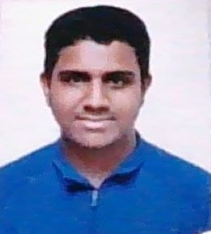
CURRICULUM VITAE

Name :Maruf Ahmed.
Father’s Name :Md Mokhlis Miah.
Mother’s Name :Mst Abida Akter.
Present Address :Vill: Dhoradhorpur,Thana:South Surma,Sylhet.
Permanent Address :Vill: Dhoradhorpur,Thana:SouthSurma,Sylhet.
Date of birth :06 July,2000.
Nationality :Bangladeshi.
Marital Status :Single.
Educational Quqlification :
Exam | Group | Board | Year
H.S.C | Science | Sylhet | 2019
S.S.C | Science | Sylhet | 2017

