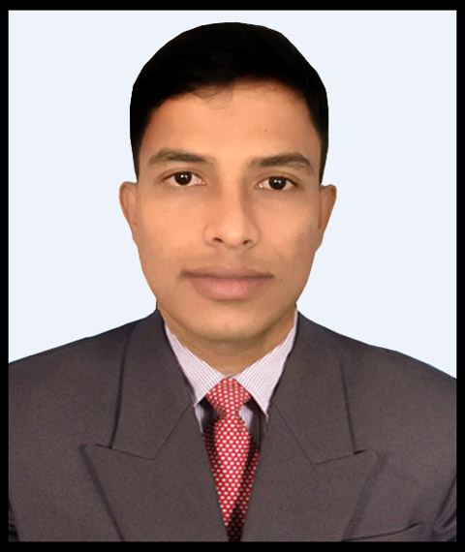Curriculum Vitae of
Md. Majadur Rhaman
Mobile No: 01797939193

CAREER OBJECTIVES :
I want to utilize the opportunity of the future for developing new policies and want to work in an environment that emphasizes for building career in a reputed company having state of the art facilities.

ACADEMIC QUALIFICATION :
Name of Exam | Institute Name | Passing Year | Division/GPA | Board
S.S.C | Pirganj Pilot High School | 2014 | 4.63 | dinajpur
MATS | Rangpur City Medical AssistantTraining School, Rangpur | 2018 | Passed | The State Medical Faculty of Bangladesh

PROFESSIONAL TRAINING :
Month | Hospital
9 (01-07-2018) to (31-03-2019) | Adhunik Sadar Hospital Thakurgaon
3 (01-05-2019) to (31-07-2019) | Upazila Health and Family Planing Office , Sadar Thakurgaon

KEY COMOPETENCE :
- Ability to work in a wide range of environment with a minimum supervision
- Good interpersonal and communication skills
- Capability to Work Under pressure and meet the organizational demand
- Ambitious and target oriented
- Able to work individually and in a team

PERSONAL PARTICULARS :
- Name : Md. Majadur Rhaman
- Date of Birth : 03th November 1998
- Fathers Name : Md. Abul Kasem
- Mothers Name : Mst. Majeda Khatun
- Permanent Address : Vill-Birholy, P.O-Birholy, P.S-Pirganj, Dist : Thakurgaon
- Nationality : Bangladeshi
- Religion : Islam
- Blood Group : A+ (Positive)
- Marital Status : Single

EXPERIENCE :
- Adhunik Sadar Hospital Thakurgaon 1 Years
- Adarsha Clinic and Nursing Home, Pirganj, Thakurgaon 5 Month
I Certify that all information stated in this resume is true and complete to the best of my knowledge.

Sincerely
…………………
Md. Majadur Rhaman

