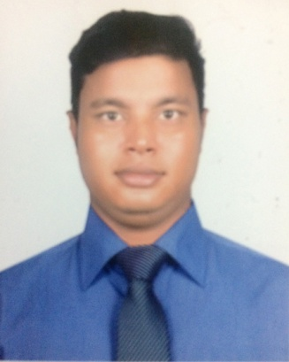
MD.MAMUNUR RASHID
House#30, Road#12, Sector#13, Uttara, Dhaka-1230.
Cell: +8801922281770,+8801936807992.
Email: mamunurrashid4792@gmail.com

CAREER OBJECTIVE:
With an experience on Educational background, my objective is to build up a carrier in any sector which would allow me to achieve a dynamic and challenging job, where I can use my interpersonal skills, creativity and above all my learning experience.

WORKING EXPERIENCE:
Crown knitwear Limited

Jacquard (Stoll) programming: 1 years

ACADEMIC QUALIFICATION:
Award | Name of Institute | Year | Discipline | Grade/ CGPA
BBA | Southeast University | 2019 | Finance | 3.19
HSC | Dhaka Megacity college | 2011 | Business Studies | 4.00
SSC | Chandona High School | 2009 | Business Studies | 4.06

PARTICIPATION IN TRAINING:
SL | Name of Workshop/ Training | Trainer / Institute
1. | Participated in “Southeast University Intra Case Competition 2017” | CPDS, Southeast University
2. | Workshop on Communication Skills | CPDS, Southeast University
3. | Workshop on Presentation Skills | CPDS, Southeast University
4. | Workshop on PowerPoint and Animation | CPDS, Southeast University
5. | Attending in a workshop on “Career Opportunities & Challenges For Finance Graduates” | CPDS, Southeast University
6 | Participated in “Southeast University TVC Scope Competition” | Business Innovation Forum Clubs, SEU

EXTRA-CURRICULAR ACTIVITIES:

- General Member of Southeast University Sports Club
- Worked as a volunteer of Doers Foundation.

COMPUTER SKILLS:

- MS Office Suite (Word, Excel, PowerPoint)
- Internet Browsing & E-mail Correspondence.

LANGUAGE PROFICIENCY:

- Bengali: Writing, Understanding and speaking abilities - Excellent.
- English: (Intermediate).Speaking, reading & writing.

OTHER ACTIVITIES:

- Pious and Attentive
- Active Learner
- Punctual and Truthful
- Can Work Under Pressure
- Excellent Communication Skill with All Varieties of People.

PERSONAL INFORMATION:
Father’s Name : Md. Mofizur Rahman
Mother’s Name : Mrs. Joygan Nasa
Date of Birth : 10th December, 1993
Nationality : Bangladeshi
NID Number : 19933313023000180
Facebook : https://www.facebook.com/mamunchowdhury

REFERENCE:

Mr. Md. Mofizur Rahman
General Manager (Production)
Crown knitwear Ltd.
Mobile: 01729097180
Email: mofiz-ckwl@crownfashionbd.net
Mr. Khairul Alom

Senior Lecturer (SBS)
Southeast University
Mobile: 01817182135
Email: khairulalom@yahoo.com

Signature

……………………………….
(Md. Mamunur Rashid)

