CURRICULUM VITAE
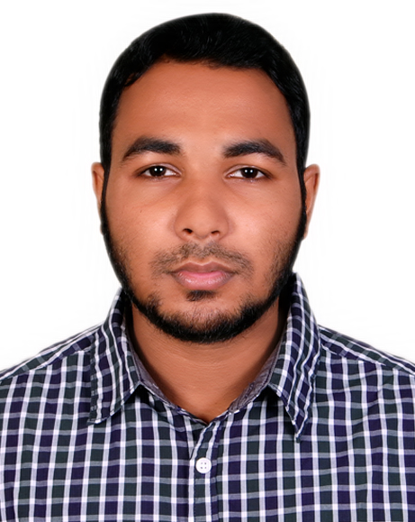

of
MARUF HUSSAIN

Contact Address And Number:
Maruf Hussain
S/O- Shahab Uddin & Ruksana Begum
Vill : Shilghat, P.O: Dhakadakshin, P.S: Golapganj, Dist: Sylhet.
+8801880-580639
Acadmic Qualification :

HSC Institution : Dhaka Dakshin M.L High School &
College.
Board : Sylhet
Discipline : Humanities
Passing Year: 2016
Result : 3.50 out of 5.00
SSC Institution : : Dhaka Dakshin M.L High School &
College.
Board : Sylhet
Discipline : Humanities
Passing Year: 2014
Result : 3.81 out of 5.00

Language :

Languages : Bengali, English
Personal Details :

Name : Maruf Hussain
Father’s Name : Shahab Uddin
Mother’s Name : Ruksana Begum
Permanent Address : Vill : Shilghat, P.O: Dhakadakshin, P.S:
Golapganj, Dist: Sylhet, Bangladesh.
Present Address : As Above
Home District : Sylhet.
Date of Birth : 13 Oct 1997
Marital Status : Unmarried
Religion : Islam
Contract number : +8801880-580639

......................................
Maruf Hussain

Date :

