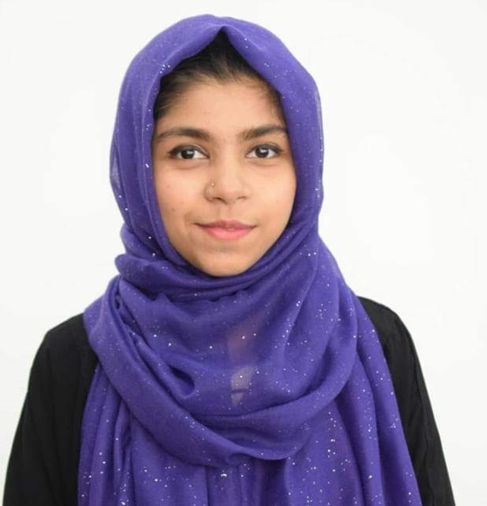
Masheyat Khan Nayema
Address : House No 42, khan House, Jollarpar, Sylhet
Contact : 01717540195
Email : mashiaatkhan92@gmail.com
Career Objective

To be a part of an organization that provides good opportunities for the growth and self-development. I have a keen interest in to face challenges with innovative thoughts along with upgrade working knowledge in the dynamic and creative arena of a reputed organization.
Employment History
- Total Year of Experience: 1 Year 8 Month
- Customer Care Officer (January 01, 2017 - Continuing)

- Company Name: Al Haramain Hospital Pvt Ltd.
- Company Location: Sylhet
- Department: Administration

Academic Qualification:
Exam Title | Concentration/Major | Institute | Result | Pas.Year | Duration
BBA | Finance and Banking | Metropolitan University, Sylhet | CGPA: 2.81  out of 4 | 2018 | 4
HSC | Business Studies | Sylhet commerce college, Sylhet | CGPA: 4.70  out of 5 | 2012 | 2
SSC | Humanities | Osmani medical high school, Sylhet | CGPA: 4.06  out of 5 | 2010 | 2

Computer Skills:
- Operating system Windows 2007, 2010, MS Word, MS Excel, MS Access & Internet Browsing.

Career and Application Information:

Looking For : Mid Level Job
Available For : Full Time
Present Salary : Tk. 15000
Expected Salary : Tk. 20000
Preferred Job Category : Customer Care Management, Administration, HRM
Preferred District : Anywhere in Bangladesh.
Preferred Organization Types : Financial Institution, Telecommunication,
Multinational Companies, Airline
Extra Curricular Activities:

- I have been working as a Customer Communicate at Event Management Programme at Grameen Phone, Banglalink & Several Mobile Networking Company at Sylhet since December 2013.
Language Proficiency:
Language | Reading | Writing | Speaking
Bengali | High | High | High
English | High | High | High

Personal Details:
Name : Masheyat Khan Nayema
Fathers Name : Abdul Basit Khan
Mothers Name : Nazma Khan Ruhi
Date of Birth : 20 August 1993
Nationality : Bangladeshi.
Permanent Address : 42, khan House,Jollarpar,Sylhet
Home District : Sylhet
Sex : Female
Marital Status : Unmarried
Religion : Islam

Reference:
Mohammad Jamal Uddin
Associate professor
Metropolitan University, Sylhet.
Cell: 01680264028

Signature

__________________
(Masheyat Khan)

