
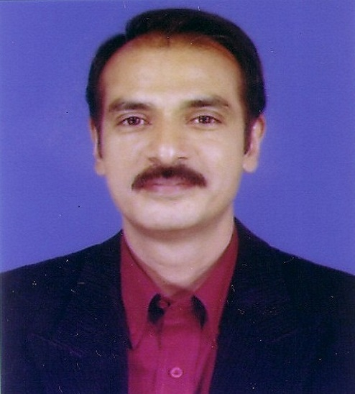

SUMMARY
Experience: 25+ Years
Education: Design & Engineering
Industry: Real Estate and Manufacturing

AREA OF EXPERTISE:
Project Coordination (lead role)
Operations Management
Sales, Marketing, Client Handling
Design & Theme
Administration

CONTACT:
70/A, Dhaka Housing Society North Adabar, Dhaka-1207
E-mail: buduby@gmail.com
Contact # 01819-262179

Masud Hossain Biswas
Career Profile

CAREERSUMMARY

Having diverse work experience of more than 25 years of Manufacturing, Operations, Sales, Marketing, and Design in Interior design industry.


KEY SKILLS

Design and Theme Planning
Monitoring and Administration
Interior Design Project Management
Cross-functional Management
Operations Management
Team Building & People Development


CAREER HISTORY

# Last Position: CEO
Company: Negoar Design Pvt. Ltd.
(1997-2016)
Responsibilities: Client dealing, Theme Planning, Estimation, Design & Project Execution etc.

# Previous Position: Factory in-charge
Lameeco Pvt. Ltd Dhaka.
(Jan 1994- Jun 1996)
Responsibilities: Looking after production of Cultured Marble Slabs and Sanitary Wares.

# Previous Position: Assistant Manager (Sales)
Bangladesh Welding Electrode Pvt. Ltd.
(A Collaboration Project with Orlikon Zurich, Switzerland)
(Oct 1992-Jun 1993)
Responsibilities: Selling and Demonstration of welding products to different Industries in Bangladesh.

# Previous Position: Sales and Service Engineer
Erba Ltd. Dhaka
(Dec 1989-Sep 1992)
Responsibilities: Demonstration of Low Heat input Welding products at different Industries in Bangladesh.

CAREER HISTORY (contd.)

# Previous Position: Sales Executive
M. Hassan & Company
(Jun 1987 - Nov 1989)
Responsibilities: Looking after sales promotion and after sales services of Sandvik Cutting Tools, Singapore.

# Previous Position: Assistant Manager (Spare & Stores)
Runner Motor Pvt. Ltd
(Apr 1986- May 1987)
Responsibilities: Maintenance of Vehicle & Inventory of spares.

# Previous Position: Technical Officer
UNDP/FAO project BGD/82/003
(Apr 1985 - Mar 1986)
Responsibilities: Installation and maintenance of poultry Cages and Inventory of Spears & Stores.

ACADEMIC BACKGROUND

Name of Degree & Institution Year

# Diploma in Interior- Exterior Design and Decoration 1996 1 Year Diploma

Jointly organized by Exterior Interior Pvt. Ltd. India

and Berger Paints BD Ltd.

# Diploma in Mechanical Engineering

Technical Education Board, Dhaka 1984 3 Years Diploma

# Higher Secondary Certificate
Jessore Board 1980

# Secondary School Certificate
Jessore Board 1977

TRAININGS

- Basic training on protective maintenance low heat input welding technology
Under Cosmic Fontech Ltd. Mumbai, India.

- Basic training on protective maintenance low heat input welding technology Eutectic+Castolin) under Larsen & Toubro Ltd. Mumbai, India.

- Basic Training on Fork lift and Crane maintenance at Chalna Port Authority, Khulna.

PERSONAL DETAILS

Date of Birth January 22, 1963
Marital Status Married, 2 children
Nationality Bangladeshi
Religion Islam

Permanent Address: “Shyamolee”
Sharif Amzad Hossain Sarak,
Pabla, Daulatpur, Khulna.

Present Address: 70/A, Dhaka Housing Society,
North Adabar, Dhaka-1207

Email Address: buduby@gmail.com
Phone: +8801819262179

DOCUMENTS & REFERENCES

Available upon request

Masud Hossain Biswas

