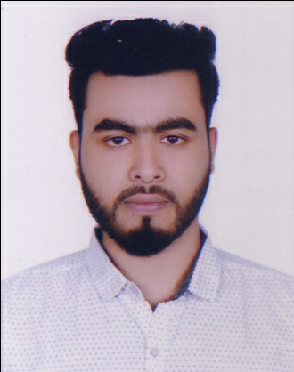
CURRICULUM VITAE
OF

Masud Rana
+8801684-159370, 01777-864596

E-mail: loverboyomi2@gmail.com

Career Objectives:

Willing to build up career in a challenging position and to prove myself as a quick learner and highly energetic person to face any challenge in the Information Civil Technology sector where the contribution will be acknowledged, if would be given an opportunity.
Educational Qualification:

- Diploma-In-Engineering: -
- Name of the institution : Model Institute of Scienc & Technology.
- Technology : Civil Technology.
- Roll no : 857158
- Passing year : 2018
- Obtained C.G.P. A : 3.03( Out of 4.00)
- Board : Bangladesh Technical Education Board, Dhaka.
- Secondary School Certificate: -
- Name of the institution : Bangladesh Mechine Tools Factory Ltd.
- Group : Science
- Passing year : 2014
- Obtained G.P. A : 3.44 (Out of 5.00).
- Board : Dhaka

Achievements :

- Strong communication and interpersonal skills.
- Good analytical and problem solving skills.

Computer Liability:
- Computer Experience – 3 Year
- Any Type Writing English & Bangla
- Computer Such as official program , Software , Hardware , Droing , Ms- Word,MS – Excel, Ms- Power Point, Windows operating System & Networking.
Extra Ordinary:
- Graphics Desing-
- Know As Adobe - Collection All
- Auto Cad 2D, 3D & (Max)
- Revite Arthacture Building Design.

Industrial training & practice:

- Organizaton Name : Greentech Design & Consultancy
- Address : DUET, Gazipur
- Duration : Three Months
Language Skills:

- 1. Bangla : Mother Language
- 2. English : Excellent.

Relevant Skills:

- Capable of working in a team as well as independently.
- Comfortable with working long hours in the site as well as an organization.
- Fluent in speaking, writing & listening in both English and Bengali.

Personal Information:

- Name : Masud Rana
- Father’s Name : Md. Liton Howlader
- Mother’s Name : Beauty Begum
- Nationality : Bangladeshi (by birth).
- Religion : Islam.
- Sex : Male.
- Marital Status : Unmarried.
- Date of Birth : 04-02-1998
- Hight : 5 Fit 6 Inch
- Birth Place : Barishal.
Present Address :
- Village : Shemultuly
- Post Office : B.O.F –(1703)
- Police Station : Gazipur Sadar
- District : Gazipur.
Permanent Address :
- Village : Hayatshar
- Post Office : Churamon
- Police Station : Kawniya
- District : Barishal.
Interests:
Reading Books and News Paper, Listening Music, Swimming , Computer Activities. Tree
Plantation at Village.

Declaration:
“I do hereby declare and certify that all the information stated above in this curriculum vitae are true and complete to the best of my knowledge and belief”.



Date: ……………………
(Masud Rana)

