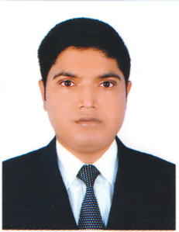
Present Address:

House # 32/33, Holding# 1169, Vill: Kunia Pachor, PO# National University, PS: Gazipur Sadar, Gazipur.
Ring - +88-01404-823620

Career Objective:
To gain a challenging position in well-reputed organization that will utilize my talent properly and provide me with the opportunity of enhancing my skill and professionalism.
Job Experience:
- Work Experience As a Sales Executive from 2018 to till, Infinity Mega Mall SB Plaza, Plot # 37, Sector # 03, Uttara, Dhaka-1230 Tel: 8914380.
- Work Experience As a Customer Sales Executive from 2014 to 2015, Tesco, Glover Road, London, N18 3HF, Tel: 03456779691.
- Work Experience As a Customer Sales Executive from 2011 to 2014 Wickes, Raven Side Retail Park, London, N18 3HA, Tel: 02088030111.
Educational Qualification:

Bachelor of Arts (Fazil):
Institute Name : Tamirul Millat Kamil Madrasha
Board : Madrsha
Passing year : 2007
Result : First Class

Higher Secondary Certificate (ALIM):

Institute Name : Tamirul Millat Kamil Madrasha
Board : Madrsha
Passing year : 2005
Subject : Humanities.
Result : GPA- 3.75

Secondary School Certificate (DAKHIL):
Institute Name : Tamirul Millat Kamil Madrasha
Board : Madrasha
Subject : Humanities.
Result : GPA-4.00
Passing Year : 2003

Computer Literacy:
Experience in computing, skills in all office program & Operating system. Windows XP, MS Office (Ms. Word, Excel, Power point) and Internet Browsing.
Language Proficiency:
Working knowledge of English, Bengali & Hindi.

Personal Information:

Father’s Name : Late Abdur Rob
Mother’s Name : Shahnaz Rob
Nationality : Bangladeshi (by Birth)
Religion : Islam (sunni)
Date of Birth : 15th October, 1988.
Height : 5.7 feet

Permanent Address:

House # 32/33,
Holding# 1169,
Vill: Kunia Pachor,
PO# National University,
PS: Gazipur Sadar, Gazipur

Declaration:

“I do hereby declare and certify that all information stated above is true and complete to the best of my knowledge and belief”.

Masudur Rahman

