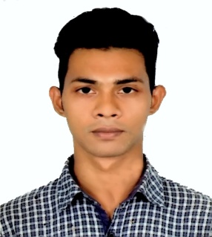
MD. MAZHARUL ISLAM
House No: 23/5, T&T Colony, Motijheel, Dhaka-1000
Mobile No: +88 01891-983692
Email: mazharul3014@gmail.com

CARRER OBJECTIVE
To build career in a growing organization, where I can get the opportunities to prove my abilities by accepting challenges, fulfilling the organizational goal and climb the career ladder through continuous learning and commitment.

EXPERIENCE
- Huawei Mobile Bangladesh, Dhaka
Retail Manager (RM)
1st April, 2017- 31st September, 2017

- Maintains the stability and reputation of the store by complying with legal requirements.
- Maintains store staff by recruiting, selecting, orienting, and training employees.
- Achieves financial objectives by preparing a monthly budget.

- Samsung Mobile Bangladesh, Dhaka
Samsung Experience Consultant (SEC)
05th February, 2016 – 31st March, 2017

- Welcomes customers by greeting and offering them assistance.
- Advises customers by providing information on products.
- Contributes to team effort by accomplishing related results as needed.
EDUCATIONAL QUALIFAICATION
- Bachelor of Business Administration (BBA)
Duration: 4 Years
Eastern University, Dhaka
CGPA: 3.40 (6th Semester Running)

- Higher Secondary Certificate (HSC)
Duration: 2 Years
National Ideal College, Dhaka
GPA: 5.00

- Secondary School Certificate (SSC)
Duration: 2 Years
Motijheel Model High School & College, Dhaka
GPA: 4.38

ADDITIONAL SKILLS & INTEREST

- Speak and write in fluent Bangla and English.
- Proficient in Microsoft Office including Excel and PowerPoint.
- Excellent written and verbal communication skills.
- Interest: Photography, Online Gaming
REFERENCE
- Mr. Oli Ahad Thakur
Chairperson and Associate Professor
Eastern University
Telephone (Office): 9676031-3
Email: oliahad@easternuni.edu.bd
Relationship: Academic

- Mohammad Tasadduk Ali Miah
Lecturer
Eastern University
Telephone (Office): 9676031-5
Email: mdtasadduk.fba@easternuni.edu.bd
Relationship: Academic

I hereby, declare that all the information mentioned above is true to my knowledge.

