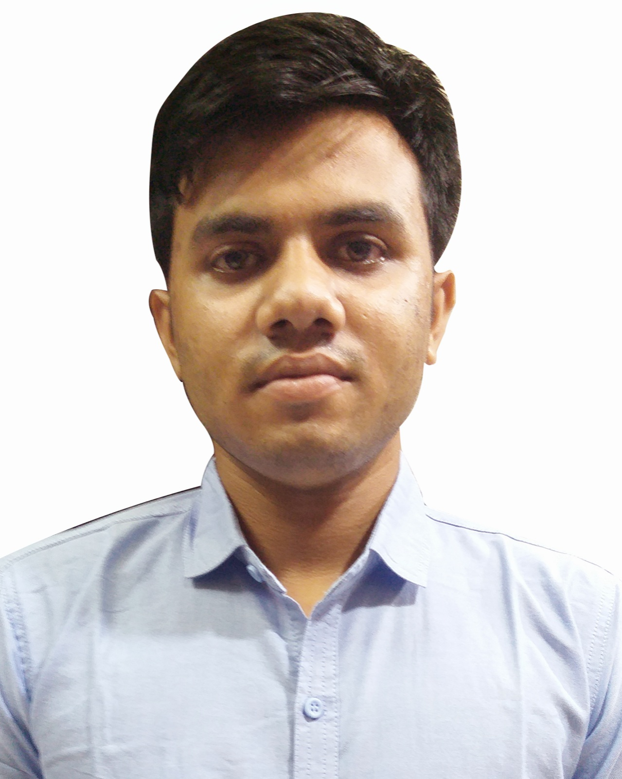
CURRICULUM VIATE

Md.Alamin

Dighinala,Khagrachari.
Phone-01864508944
Email- mdalamin89216@gmail.com

Career Objective

To work on a challenging job profile which provides an opportunity to enhance my technical skills and knowledge, this could provide me an insight into new aspects so that it would be helpful for my career.

Education

- SSC(science), 2013-2014.(GPA-3.94) from Natunkuri Cantonment high school,khagrachari

- Completed HSC(Science).(GPA-4.75) in 2015-2016 batch from Sristy Central School And College, Uttara,Dhaka.
.
- Honours in Department of English from Rangamati govt.college.

Strength
- Work with positive attitude to contribute the healthy functioning of the organization.
- Self-Confident and Great Patience.
- Analyzing every angle of a project before working on it.
- Willingness to Learn.
- Adaptability to change environment.
- Ability to creat new retailer and dealer.
- Strong relationship with customer,retailer and dealer.

Work Experience
★SEC at Samsung,Mobile brand till now working here.
★1.5 year job experiens at OPPO mobil company ltd as a senior brand promotor.
Working experience with Dealer house.
Skills

.★computer skill
★MS word,excel,office.
★Conversational English.
★Ability to retail convince.
★Ability to maintain RSA at and Meneger at showroom.
★Creating Market by relationship with retail owner.
★Strong Leadership.
★Ability to take challenges and achive Target.
★Ability to maintain outlate.

Personal details
Date of Birth : 07 January 1998
Nationality : Bangladeshi
Gender : Male
Father’s Name : Md.Muslim Uddin
Mother’s Name : Anowara Begum
Languages known : Bangla,English, Hindi.
Hobbies : Listening Music, Playing Cricket,.
Marital Status : Unmarried
Permanent Address. : Dighinala,khagrachari.
Present. Address : Banorupa,Rangamati.
Mobil. : 01864508944
Email. : mdalamin89216@gmail.com

Declaration

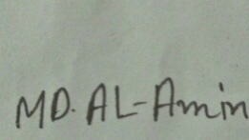
I hereby declare that the above information is true to the best of my knowledge and belief.

Date: 26-01-2019 Md.Alamin

