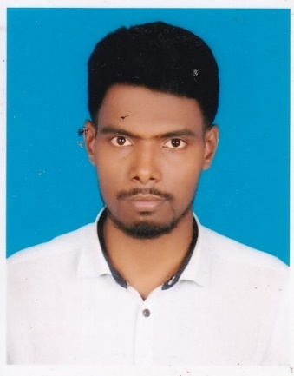
Resume of
MD.MILON HOSSIN
B.Sc. in Civil Engineering
Cell: 01740-291767

Address: House#39,Road#08,Block-H, Mirpur-2, Dhaka-1216.
Mobile No: 01740-291767
E-mail: milonbd2015bd@gmail.com
CAREER OBJECTIVE
To work for an organization which provides thepotentials for advancement, and will enableutilization of my abilities and will challengemy intellect. I believe that I possess necessary functional and technical expertise towards positively contributing to the growth of the organization.
PROFESSIONAL EXPERIENCE

- Aesthete Ltd. (a sister concern of Shagufta Group)
Address : House # 549, Road# 6, DOHS Mirpur-12, Dhaka-1216,
Position: Site Engineer
Duration: January 01, 2018 to Continue.
Type of assignment: Building Construction (Real Estate Sector)
Major Responsibilities:
- Planning & monitoring the progress of the project.
- Supervise all maintenance & Other's.
- Ensure quality of work at every phase of construction by maintaining checklists and appropriate procedures.
- Study all drawing and maintain work accordingly.
- Coordination for materials delivery on time.

- Update master plan considering daily progress
- Submit and follow up the requisition of materials for project
- Dynamic Engineers & Consultants Ltd.
Address: House#-11, Road#03,Block-H, Mirpur-1, Dhaka-1216.
Position: Auto Cad Detailer
Duration: October 01, 2015 to 31 December 2017.
Type of assignment: Auto Cad Drawing Design
Major Responsibilities:
    - 2Dimensional Interior, Architectural, Civil drafting by using Auto Cad.
    - Shop drawing, working drawing, as built drawing, Layout plan, elevation, section, isometric drawing and all related technical drawing and drafting.
    - Structural Drawing.
    - Measurement taking and review.
    - 3D drawing with Auto Cad.

ACADEMIC QUALIFICATION:

B.Sc. in Civil Engineering:
Institute :European University of Bangladesh, Dhaka.
Department : Civil Engineering
Passing Year : 2019
Result : GPA-3.50 (Out of 4)
Diploma in Engineering:

Institute: Brahmanbaria Polytechnic Institute, Islampur,Brahmanbaria.
Department : Architecture & Interior Design
Passing Year: 2015
Result : GPA-3.14 (Out of 4)
Board : Bangladesh Technical Education Board, Dhaka.

S.S.C (Secondary school Certificate)
School : Demra Hazi Joyen Ulla High School, Faridpur, Pabna
Group : General Electrical
Passing Year : 2010
Result : GPA- 4.27 (Out of 5)
Board : Bangladesh Technical Education Board, Dhaka.
Confidence:
I being smart, young, energetic, dynamic, an outgoing pleasant personality and self-starter, strong inter-personal skill with ability to high speed. I understand, hereby declare
that I will be responsible for any wrong information provided here.
Language Literacy:
Bengali : Reading, Writing, & Speaking.
English : Reading, Writing, & Speaking.
COMPUTER LITERACY:
MS Office, Auto CAD 2D, /Sketchup/ Internet Explore and others hardware operation

PERSONAL INFORMATION:

Name : Md. Milon Hossin
Father’s Name : Md. Jaidul Islam
Mother’s Name : Mst. Asma Khatun
Date of Birth : June 20, 1995
Nationality : Bangladeshi
Religious : Islam (Sunni)
Present Address : House # 39/08, Block-H, Mirpur-2, Dhaka-1216
Permanent Address : Vill.# Choto Pathail hat, Post: Nagdemra, P.S: Santhia, Dist.: Pabna
Email : milonbd2015bd@gmail.com

REFERENCES
Md. Monirul Islam
Senior Project Engineer
Project Engineer at Aesthete Limited
Cell: 01730-387432

CERTIFICATION
I, hereby, declare to the best of my knowledge and belief that this resume correctly describes my qualifications, experiences and related details. Thanks for going through my resume.

Date: ……………………………. Signature

