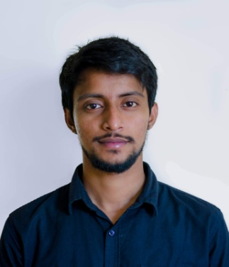
Curriculam Vitae

Biography
Name : MD. Moshiur Rahman
Father’s Name : Late Abdul Latif
Mother’s Name : Late Maqsuda Khanam
Date of Birth : 25th October , 1995
Gender : Male Marital Status : Unmarried
Religion : Islam Nationality : Bangladeshi
Parmanent Address:
Village : South Adampura P.O. : Nehal ganj
Thana : Dasmina Zilla : Patuakhali

Skills and Personal Qualities
- Project management  - Strong decision maker  - Fluent in both Bengali and English | - Honest  - Innovative  - Dedicated  - Hard working

Academic Background
M.Sc Masters ( Statistics )
CGPA : 2.95 out of 4.00 Passing Year : 2019
Shahjalal University of Science and Technology, Sylhet

B.Sc Honours ( Statistics )
CGPA : 2.81 out of 4.00 Passing Year : 2018
Shahjalal University of Science and Technology, Sylhet

Higher Secondary Certificate Examination (H.S.C)
Group : Science GPA : 5.00 out of 5.00 Year : 2013
St Joseph Higher Secondary School , Dhaka

Secondary School Certificate Examination (H.S.C)
Group : Science GPA : 5.00 out of 5.00 Year : 2011
Monipuri High School and College , Dhaka

Extra Curricular Activities
Co-convener of Maha SPORTS SUST champions League s7
Vice President of SPORTS SUST, Executive Committee of 2013
Co-Founder of ANIUK desings

Achievements
Champion , Inter-Department Football Tournament,SUST
Champion , Departmental Badminton Tournament
Champion , Inter-Department Cricket Tournament, SUST
Champion , Naveed Memorial Cricket Tournament

Contact
Phone:
01312365191

Email:
mdmoshiur.rahman1135@gmail.com

Present Address:
364/A North Pirerbag, MIrpur
Dhaka 1216

Career Objectives
To work in the Statistical data analysis sector based on statistical software of different public or private agencies like as local or multinational and grow rapidly with increasing responsibilities

Interests
- Music
- Sports
- Travelling
- Theatre
Computer Skills
- MS OFFICE (WORD,EXCELL,POWERPOINT)
- SPSS
- R Programming
- Stata
- SAS
MD.MOSHIUR RAHMAN
References
Prof. Md. Ahmed Kabir Chowdhury
Head of Department of Statistics
Shahjalal University of Science and Technology,
Phone : 01714227456 Email : makc@sust.edu

Dr. Mohammed Taj Uddin
Professor , Department of Statistics
Shahjalal University of Science and Technology,
Phone : 01716348194 Email : mtajstat@yahoo.com

I hereby declare that all the information given in this paper are true. If any inconsistency is found you can take legal masures aginst me as per your company policy.



Signature

