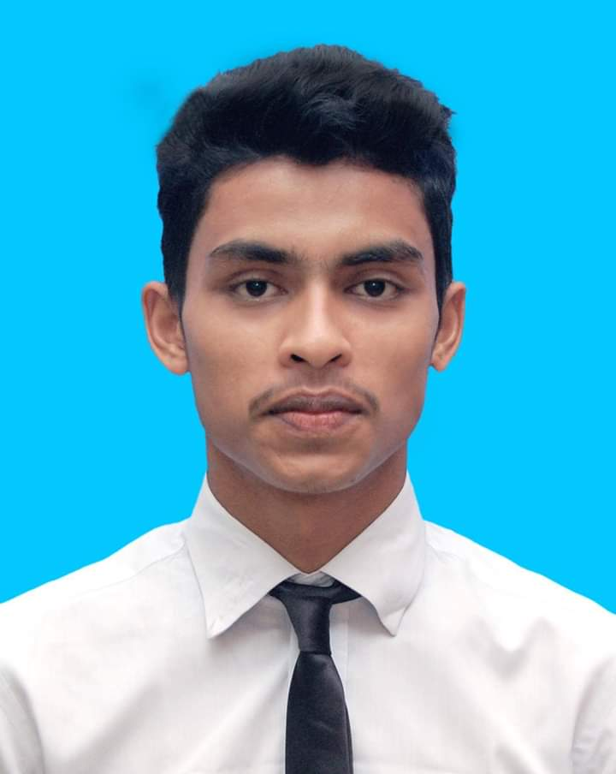
Curriculum Vitae
Of
Md Riaz Ahmed

Mailing Address:
Lawai, South Surma Sylhet-3100
Contact: +8801724346086
Email : armiofficer1@gmail.com
CAREER OBJECTIVE:

Encounter challenge with wisdom to build a career that required creativity, honesty, hard working, sincerity, patience and brilliance. Moreover to gain utmost competence in the field of required and work to enrich my job as well as to give better service to my institution, men, society, & country.

ACADEMIC CAREER:

Higher Secondary Certificate (H.S.C)
Institute : The Royal MC Academy Sylhet
Group : Business Studies
Board : Sylhet
Result : 3.58 out of 5.00
Year of Passing : 2017

Secondary School Certificate (S.S.C)
Institute : South Surma High School
Group : Business Studies
Board : Sylhet
Result : 4.10 out of 5.00
Year of Passing : 2015

COMPUTER LITERACY
- MS word, Excel, PowerPoint.
- Familiar with Internet and e-mail

Skills
- Willingness to work hard necessary to develop career.
- Self-motivation.
- Communication skill.
- Convincing power.
- Team Work.

LANGUAGE SKILL:

Good command on English and Bengali both oral and written.

INTEREST

- Traveling.
- Net-browsing.
- Reading Books.

MY PERSONAL DETAILS
Name : Md Riaz Ahmed
Father’s Name : Md Suleman Mia
Mother’s Name : Mst Julekha Begum
Permanent Address : Vill: Lawai, P.O: South Surma
P.S: South Surma, Dist: Sylhet.
Date of Birth : 08-10-1997
Religion : Islam
Marital Status : Unmarried
Gender : Male
Nationality : Bangladeshi

( Md Riaz Ahmed)

Date:

